**Supporting Information**

**Eco-friendly and Regiospecific synthesis of Novel (5-oxo-4,4-diphenylimidazolidin-2-ylidene)cyanamide Derivatives**

**Amer A. Amer1,*, Doaa H. Ahmed1, Amr H. Moustafa1,2**

*1 Department of Chemistry, Faculty of Science, Sohag University, Sohag 82524, Egypt.*

*2 Faculty of Science, King Salman International University, Ras Sudr, Sinai 46612, Egypt.*

*1*E. mail:* [*Amer_chem@yahoo.com*](mailto:Amer_chem@yahoo.com)*, Fax: +20934601950, Mobil: +201117860798*

*1E. mail:*[*sunriseh51@yahoo.com*](mailto:sunriseh51@yahoo.com)

*2 E. mail:* [amr_hassanegypt@ymail.com](mailto:amr_hassanegypt@ymail.com), [amr_hassanegypt@science.sohag.edu.eg](mailto:amr_hassanegypt@science.sohag.edu.eg)

# 1. General Information:

All commercially available reagents were purchased from Merck, Aldrich and Fluka and were used without further purification. All reactions were monitored by thin layer chromatography (TLC) using precoated plates of silica gel G/UV-254 of 0.25 mm thickness (Merck 60F254) using UV light (254 nm/365 nm) for visualization. Melting points were detected with a Kofler melting points apparatus and uncorrected. Infrared spectra were recorded with a FT-IR-ALPHBROKER-Platinum-ATR spectrometer and are given as cm-1 using the attenuated total reflection (ATR) method. 1H NMR and 13C NMR spectra for all compounds were recorded in DMSO-*d6* on a Bruker Bio Spin AG spectrometer at 400 MHz and 100 MHz, respectively. For 1H NMR, chemical shifts (δ) were given in parts per million (ppm) with reference to tetramethylsilane (TMS) as an internal standard (δ=0); coupling constants (J) were given in hertz (Hz) and data are reported as follows: chemical shift, integration, multiplicity (s=singlet, d=doublet, t= triplet, q=quartet, m=multiplet, dd=doublet of doublets). For 13C NMR, TMS (δ=0) or DMSO (δ=39.51) was used as internal standard and spectra were obtained with complete proton decoupling. Elemental analyses were obtained on a Perkin-Elmer CHN-analyzer model. Ultrasonication was carried out in a Power sonic410 apparatus (DAIHAN LABTECH Co., LTD, KOERA). The electric supply was 20 V, A.C. 60 Hz; the ultrasonic Watts 500W / 2A. serial No. 2016120709.

**General method for preparation of compounds 2-5:**

**Method A (ultrasonic irradiation):**

A mixture of CNG-DPH **1** (0.01 mol, 2.76 gm) and alkyl halide (0.01 mol) and sodium ethoxide (0.02 mol) was added to 10 ml DMF and placed in a closed vessel and exposed to US irradiation for about 3 hrs at 50 °C in a sonicator. After completion of reaction (monitored with TLC), the reaction mixture was then cooled to room temperature, poured into crushed ice. The formed precipitate was collected by filtration, washed by distilled water, dried and crystallized from ethanol.

**Method B (Conventional method):**

A mixture of CNG-DPH **1** (0.01 mol, 2.76 gm) and an appropriate alkyl halides (0.01mol) namely: ethyl chloroacetate (1.07 mL), benzyl chloride (1.15 mL), 2-chloroacetonitrile (0.63 mL) and bromoethane (0.75 mL) was added in the presence of sodium ethoxide under reflux in DMF for about 3 hrs. After completion of reaction (monitored with TLC), the reaction mixture was then cooled to room temperature, poured into crushed ice. The formed precipitate was collected by filtration, washed by distilled water, dried and crystallized from ethanol.

**Characterization Data of 2-5:**

|  |  |
| --- | --- |
| **Ethyl 2-(2-(cyanoimino)-5-oxo-4,4-diphenylimidazolidin-1-yl)acetate (2)** | |
|  | White, yield 82%, m.p. 228-230°C; FT-IR (ATR) max 3274 (NH), 3027 (CHaromatic), 2982, 2918, 2848 (CHaliphatic), 2199 (C≡N), 1745 (C=O) cm-1; 1H NMR: *δ* 1.17-1.21 (t, *J* = 7 Hz, 3H, CH3), 4.15-4.21 (q,  *J* = 7 Hz, 2H, CH2), 4.40 (s, 2H, CH2), 7.37-7.49 (m, 10H, CHarom.), 11.44 (s, 1H, NH) ppm; 13C NMR: *δ* 14.3, 41.1(exchangeable with DEPT-135), 62.1(exchangeable with DEPT-135), 72.2, 114.7, 127.5, 129.2, 129.3, 138.2, 159.4, 167.1, 173.1 ppm; *Anal*. Calcd. for C20H18N4O3 (362.39): C, 66.29; H, 5.01; N, 15.46 %. Found: C, 66.35; H, 5.15; N, 15.38 %. |
| **N-(1-benzyl-5-oxo-4,4-diphenylimidazolidin-2-ylidene)cyanamide (3)** | |
|  | White, Yield 84%, m.p: 195-197°C; FT-IR (ATR) max 3669 (NH), 3092 (CHaromatic), 2903 (CHaliphatic), 2198 (C≡N), 1745 (C=O) cm-1; 1H NMR: *δ* 4.77 (s, 2H, CH2), 7.25-7.44 (m, 15H, CHarom.), 11.41(s, 1H, NH) ppm; 13C NMR): *δ* 43.3 (exchangeable with DEPT-135), 71.9, 114.9, 127.3, 127.8, 128.3, 129.2, 135.9, 138.4, 159.9, 173.3 ppm. *Anal*. Calcd. for C23H18N4O (366.42): C, 75.39; H, 4.95; N, 15.29 %. Found: C, 75.45; H, 4.74; N, 15.43 %. |
| ***N-(1-(cyanomethyl)-5-oxo-4,4-diphenylimidazolidin-2-ylidene)cyanamide*** **(4)** | |
|  | White, Yield 78%, m.p: 230-232°C; FT-IR (ATR) max 3412 (NH), 3023 (CHaromatic), 2897 (CH aliphatic), 2206 (C≡N), 1770 (C=O) cm-1; 1H NMR: *δ* 4.77 (s, 2H, CH2), 7.34-7.49 (m, 10H, CHarom.), 11.73 (s, 1H, NH) ppm; 13C NMR: δ 28.2 (exchangeable with DEPT-135), 72.3, 114.3, 115.1, 127.4, 129.3, 129.4, 137.9, 158.2, 172.1 ppm. *Anal*. Calcd. for C18H13N5O (315.34): C, 68.56; H, 4.16; N, 22.21%. Found: C, 68.66; H, 4.07; N, 22.32 %. |
| ***N-(1-ethyl-5-oxo-4,4-diphenylimidazolidin-2-ylidene)cyanamide (5)*** | |
|  | White, yield 63 %, m.p: 220°C. FT-IR (ATR) max 3372 (NH), 3047 (CHaromatic), 2987, 2969, 2903, (CHaliphatic), 2194 (C≡N), 1757 (C=O) cm-1; 1H NMR : *δ* 1.14-1.15 (*t*, *J* = 6 Hz, 3H, CH3), 3.58- 3.60 (*q*, *J* = 6. Hz, 2H, CH2), 7.33-7.45 (m, 10H, CHarom.), 11.26 (s, 1H, NH) ppm; 13C NMR: *δ* 13.2, 35.2, 71.7, 115.1, 127.4, 129.2, 138.5, 159.9, 173.2 ppm. *Anal*. Calcd. for C18H16N4O (304.35): C, 71.04; H, 5.30; N, 18.41 %. Found: C, 71.21; H, 5.55; N, 18.72 %. |

***Synthesis of N-(1-((diethylamino)methyl)-5-oxo-4,4-diphenylimidazolidin-2-ylidene)cyanamide (6):***



A solution of CNG-DPH **1** (0.01 mol, 2.76 gm) and formaldehyde (0.2 ml, 0.03 mol) was stirred in 40 ml ethanol for 30 min, then the diethylaine (0.73 g, 0.01 mol) was added and the reaction mixture was stirred for 2h. The separated solid was filtered off, washed with water, and recrystallized from ethanol to give product **6** as white

White solid, yield 83 %, m.p: 290 °C. FT-IR (ATR) max 3171 (NH), 3029 (CHaromatic), 2938, 2863 (CHaliphatic), 2178 (C≡N), 1705 (C=O) cm-1; 1H NMR : *δ* 1.16 (m, 6H, 2CH3), 2.94 (m, 4H, 2CH2), 4.13(sbr.s, 2H, CH2), 7.36-7.24 (m, 10H, CHarom.), 8.83 (br. s, 1H, NH) ppm; 13C NMR: *δ* 186.15, 175.36, 142.39, 128.38, 127.45, 127.25, 120.34, 73.10, 41.83 (exchangeable with DEPT-135), 11.48.ppm. *Anal*. Calcd. for C21H23N5O (361.44): C, 69.78; H, 6.41; N, 19.38 %. Found: C, 69.59; H, 6.37; N, 19.41 %.

***Synthesis of N-(1,3-diethyl-5-oxo-4,4-diphenylimidazolidin-2-ylidene)cyanamide (9):***



A mixture of CNG-DPH **1** (0.01 mol, 2.76 gm), bromoethane (10 mL) and sodium ethoxide (1.7 gm, 0.025 mol) and 5 ml DMF was placed in a closed vessel and exposed to US irradiation for 5 hrs at 50 °C in a sonicator. After completion of reaction (monitored with TLC), the reaction mixture was then cooled to room temperature, poured into crushed ice. The formed precipitate was collected by filtration, washed several times by distilled water, dried and crystallized from ethanol to give product **9** as white solid, Yield 59%, m.p: 128-130°C. FT-IR (ATR) max 3061 (CHaromatic), 2973, 2934, 2904 (CHaliphatic), 2190 (C≡N), 1751 (C=O) cm-1; 1H NMR : *δ* 0.49 (2, 3H, CH3), 1.17 (s, 3H, CH3), 3.74-3.76 (*d*, *J* = 5.0 Hz, 4H, 2CH2),7.27-7.50 (m, 10H, CHarom.) ppm; 13C NMR: *δ* 13.7, 14.4, 35.9, 38.7, 76.5, 114.2, 127.3, 128.6, 129.1, 129.6, 129.9, 136.1, 155.1, 172.9 ppm. *Anal*. Calcd. for C20H20N4O (332.41): C, 72.27; H, 6.06; N, 16.86 %. Found: C, 72.37; H, 5.97; N, 16.91 %.

**IR, 1H, 13C, DEPT-135 NMR Spectra of 2:**

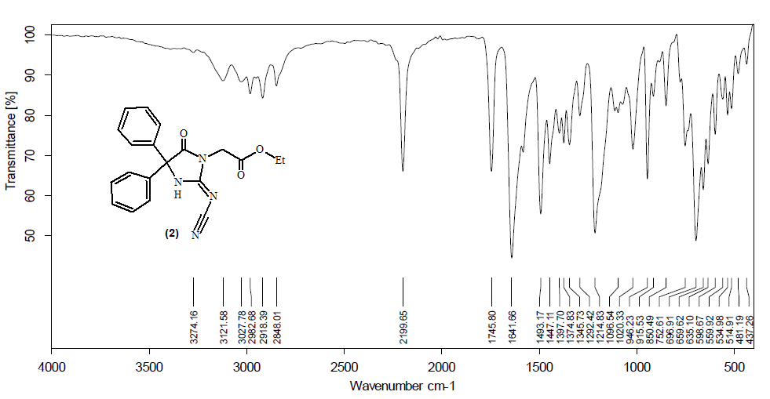

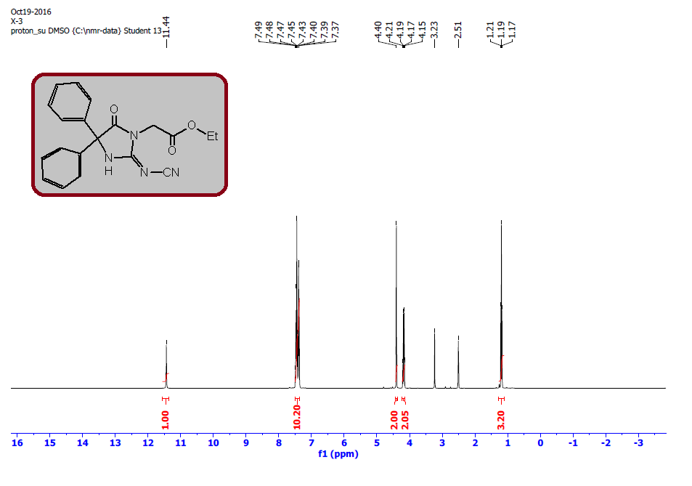

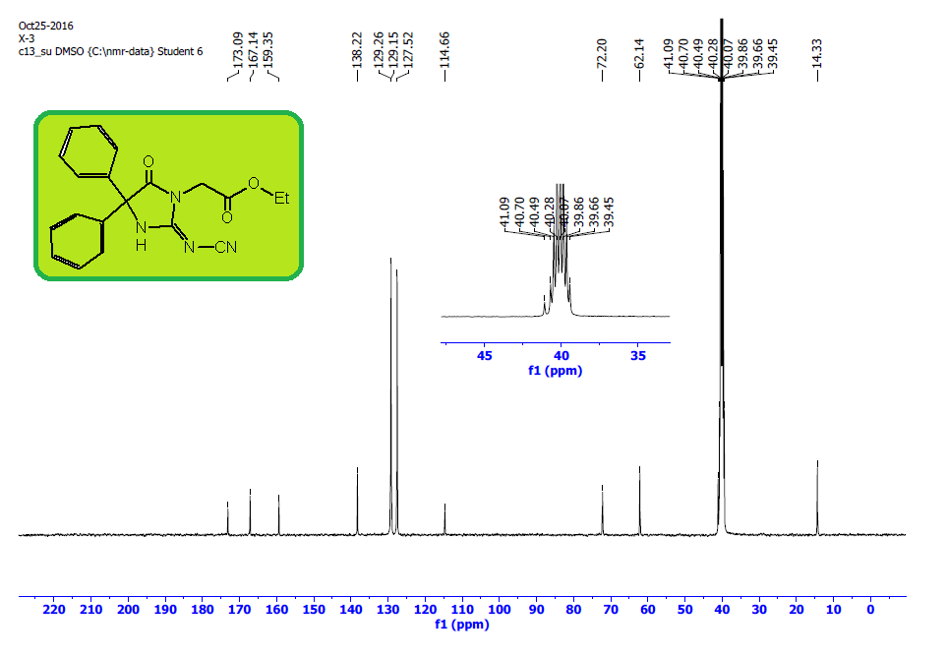

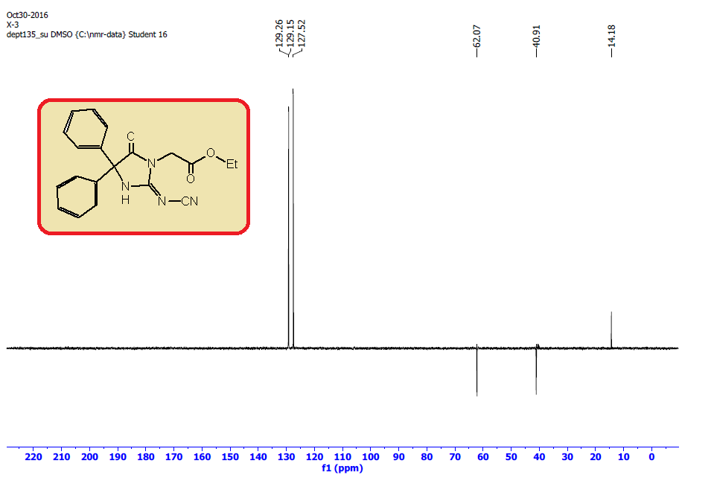

**IR, 1H, 13C, DEPT-135 NMR Spectra of 3:**

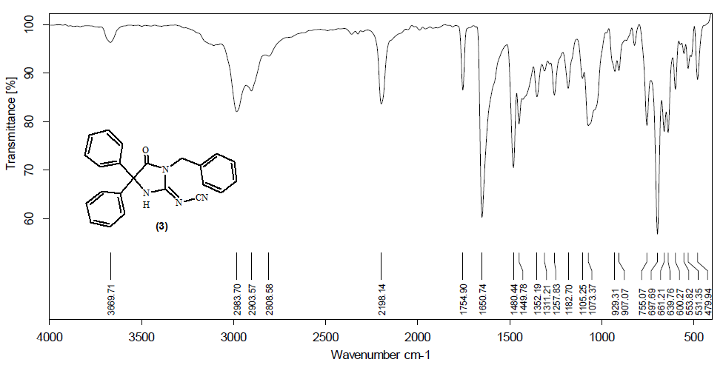

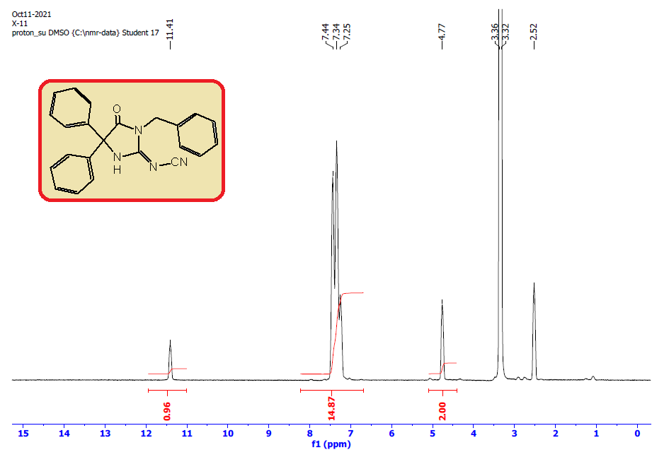

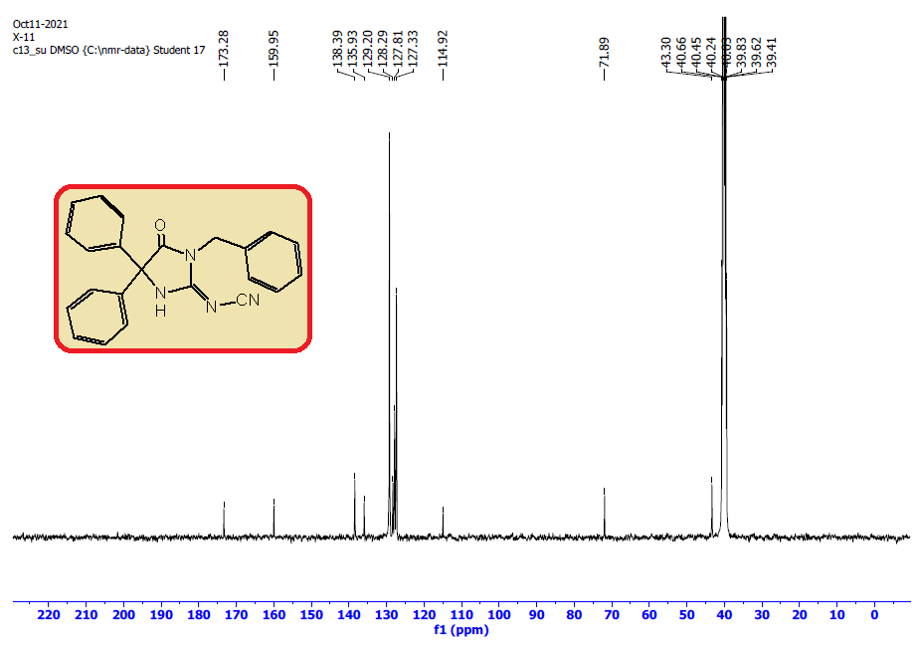

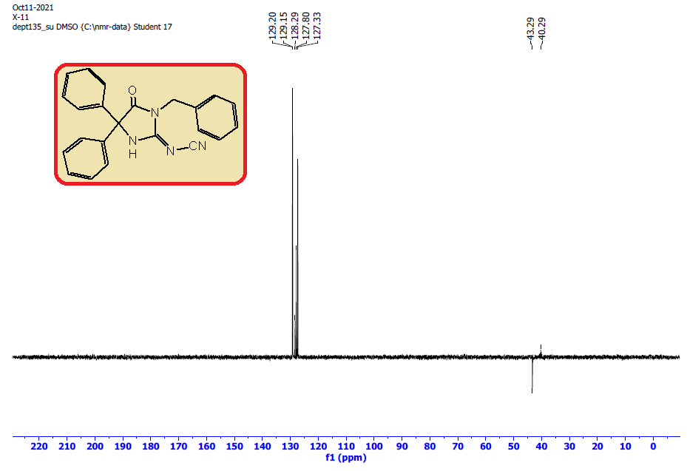

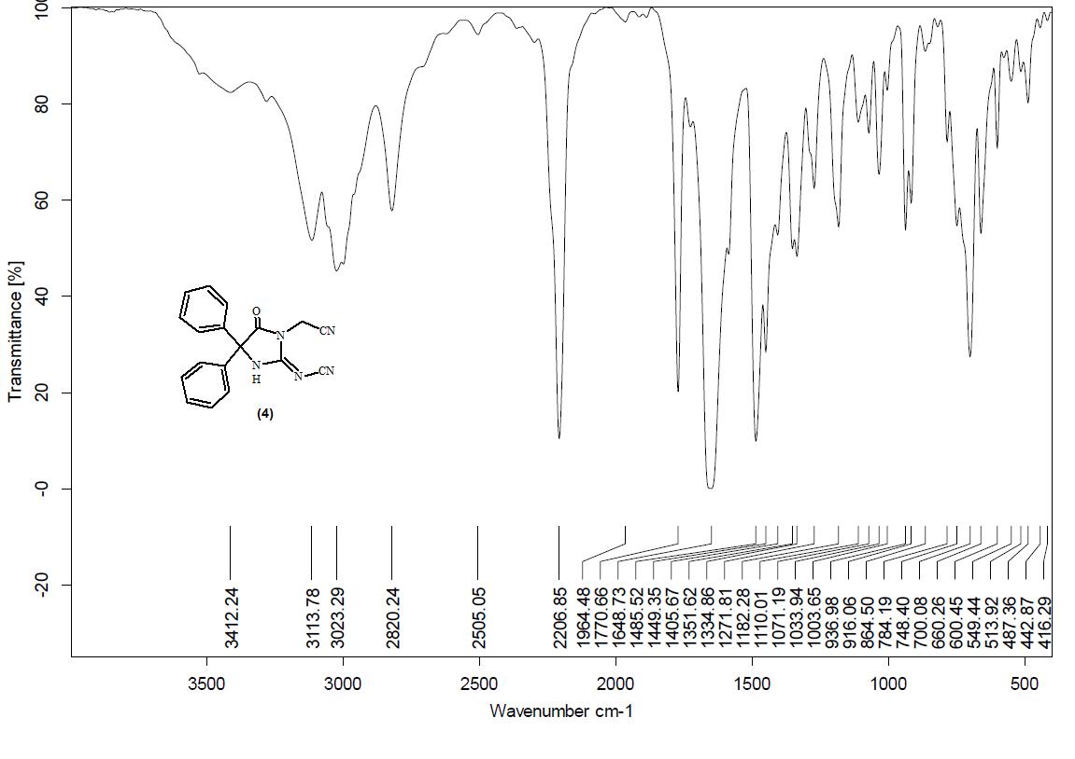**IR, 1H, 13C, DEPT-135 NMR Spectra of 4:**

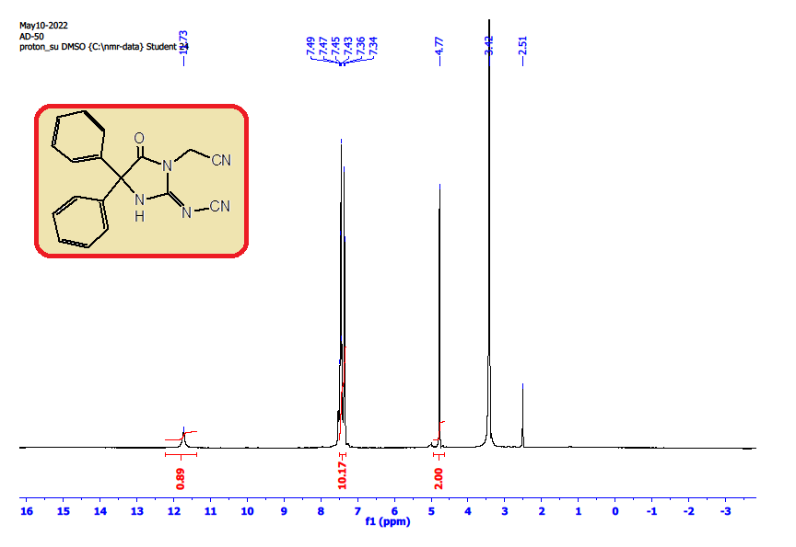

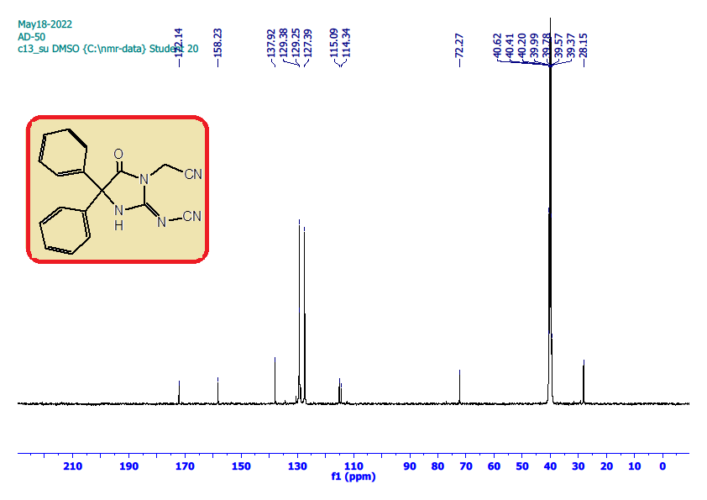

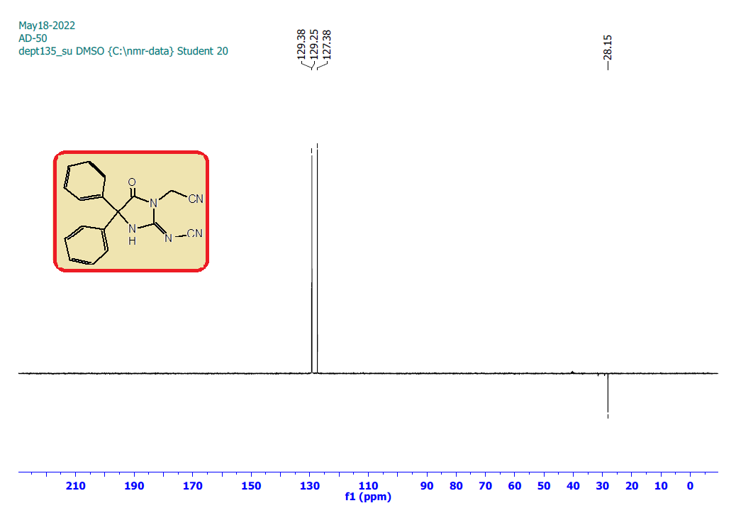

**IR, 1H and 13C NMR Spectra of 5:**

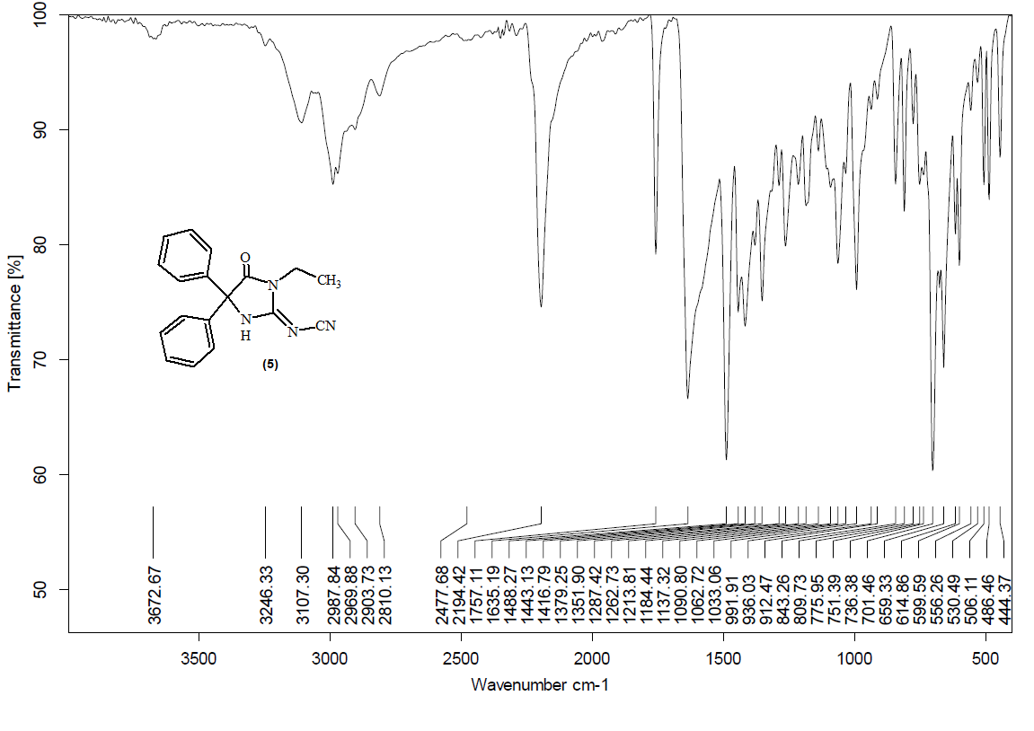

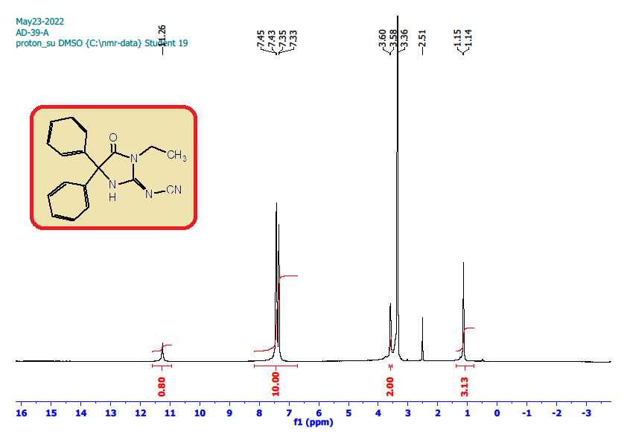

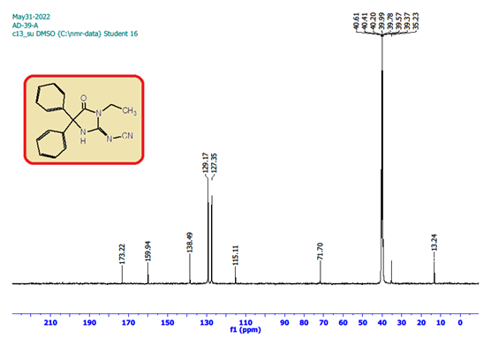

**IR, 1H and 13C NMR Spectra of6:**

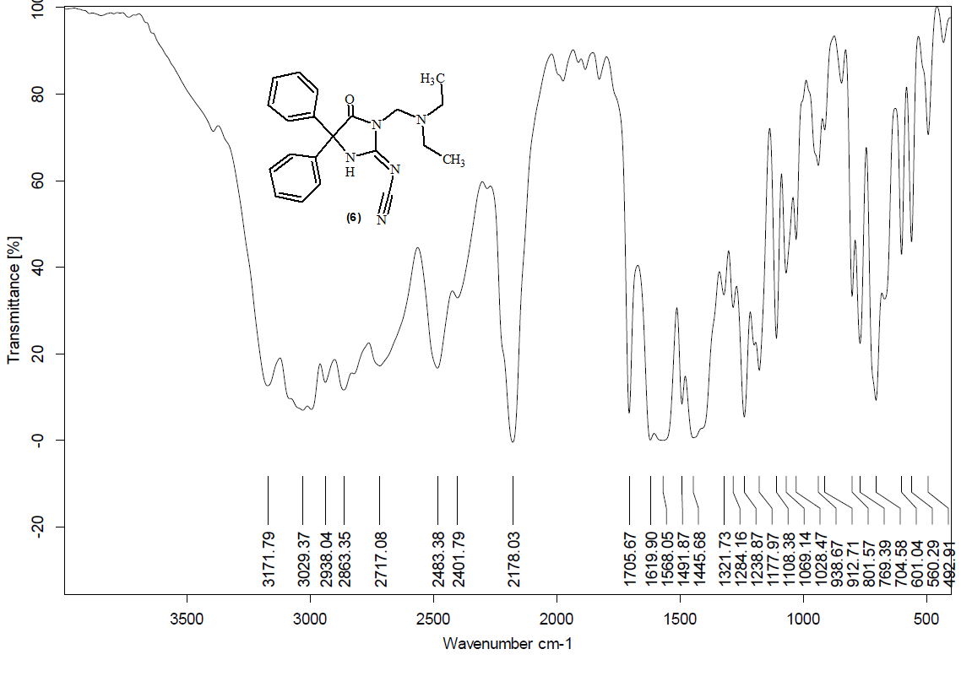

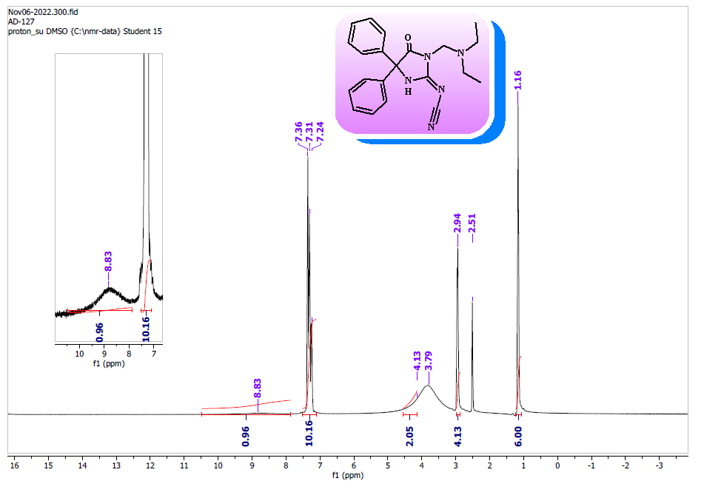





**IR, 1H and 13C NMR Spectra of 9:**

