**Synthesis and Characterization of Some Novel Indole-2-One-Coumarin Hybrids**

Omyma A. Abd Allah1*, Ehab S. M. Elkhayat2, Amr H. Moustafa1,3 and Alaa A. Fahmy1

*1 Chemistry Department, Faculty of Science, Sohag University, Sohag 82524, Egypt*

*2 Pharmacognosy Department, Faculty of Pharmacy, Al-Azhar University, Assiut branch, Egypt*

*3 Faculty of Science, King Salman International University, Ras Sudr, Sinai 46612, Egypt*

*\*Email:* [*omymatif66@yahoo.com*](mailto:omymatif66@yahoo.com)*,* [*omaima.abdelatef@science.sohag.edu.eg*](mailto:omaima.abdelatef@science.sohag.edu.eg)

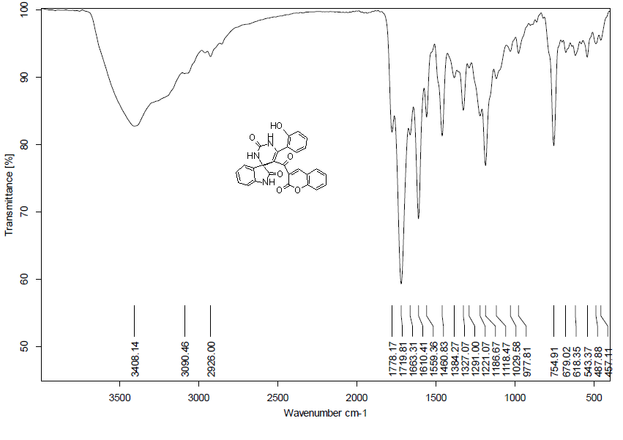

**Fig. 1:** IR spectrum of compound **3**

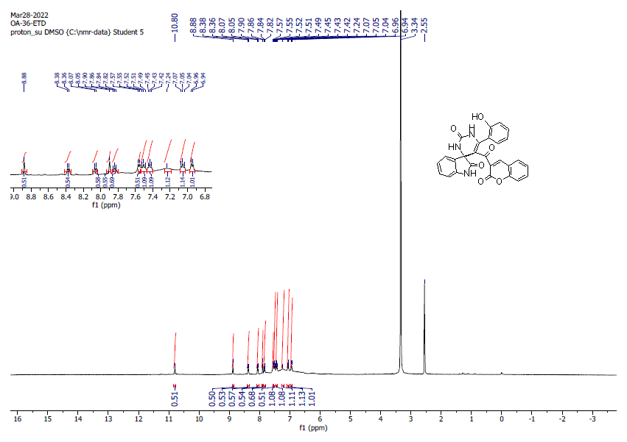

**Fig. 2:** 1H-NMR spectrum of compound **3** in DMSO-d6

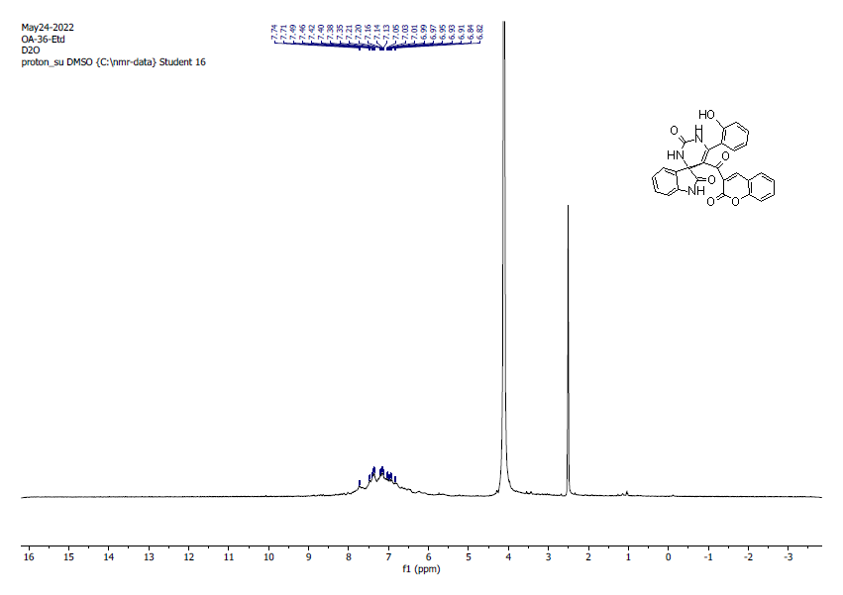

**Fig. 3:** D2O spectrum of compound **3** in DMSO-d6

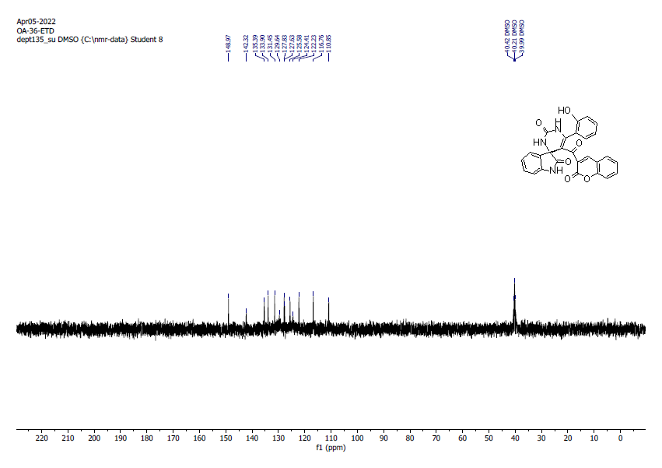

**Fig. 4:** DEPT 135spectrum of compound **3** in DMSO-d6

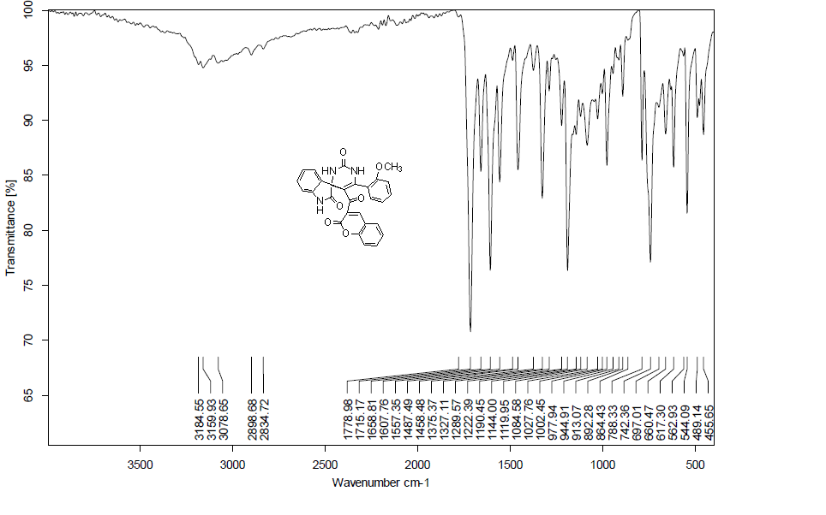

**Fig. 5 :** IR spectrum of compound **4a**

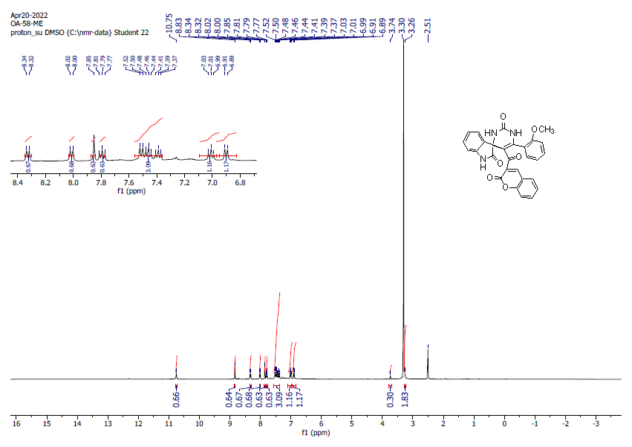

**Fig. 6 :** 1H-NMR spectrum of compound **4a** in DMSO-d6

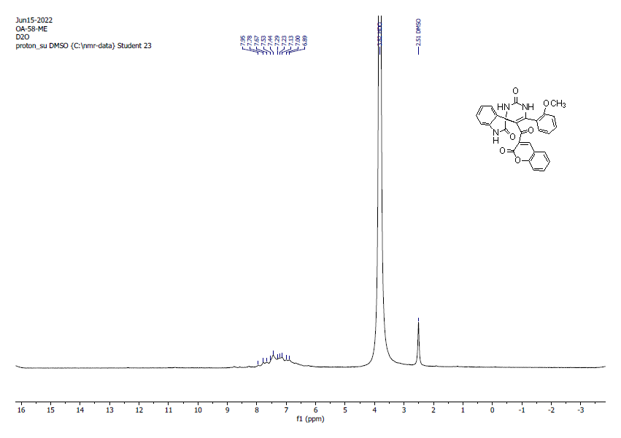

**Fig.7:** D2O spectrum of compound **4a** in DMSO-d6

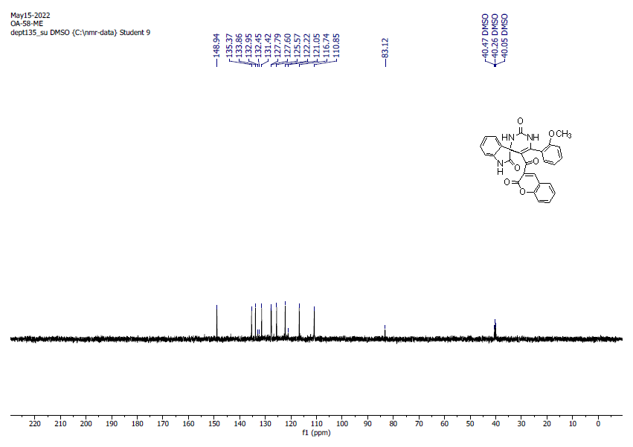

**Fig. 8:** DEPT 135 spectrum of compound **4a** in DMSO-d6

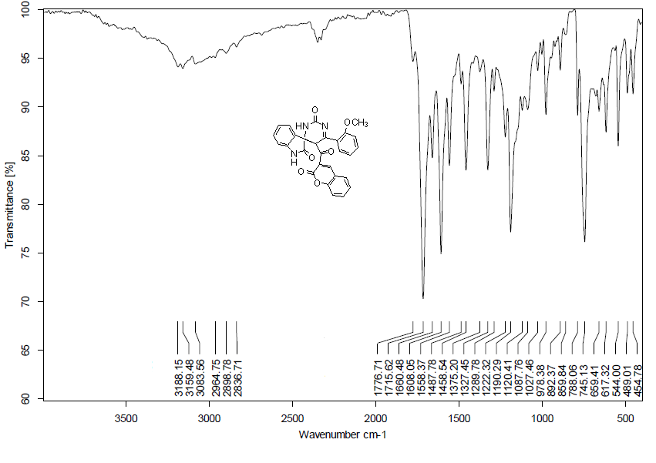

**Fig.9:** IR spectrum of compound **4b**

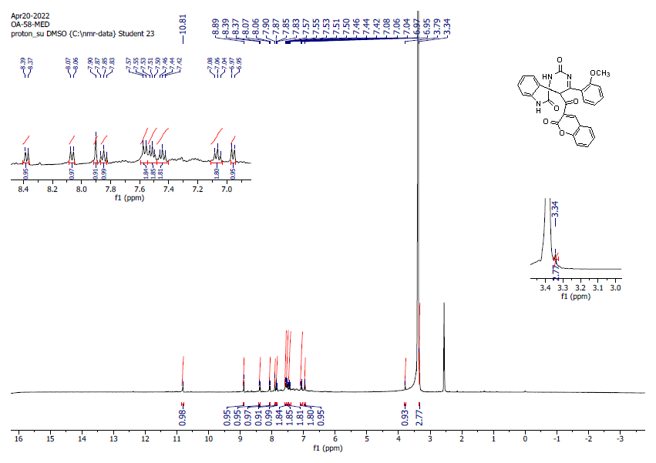

**Fig. 10 :** 1H-NMR spectrum of compound **4b** in DMSO-d6

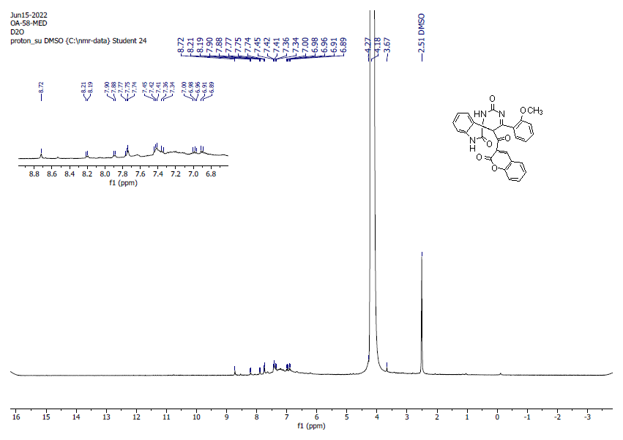

**Fig. 11:** D2O spectrum of compound **4b**in DMSO-d6

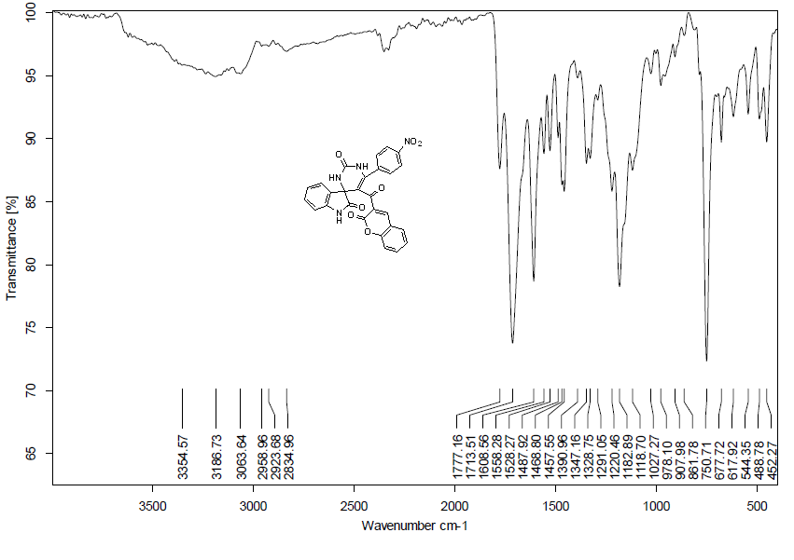

**Fig. 12:** IR spectrum of compound **5**

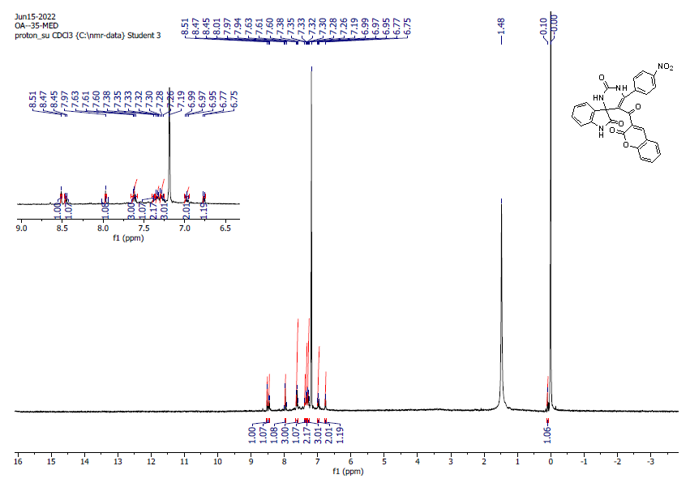

**Fig.13:** 1H-NMR spectrum of compound **5** in CDCl3

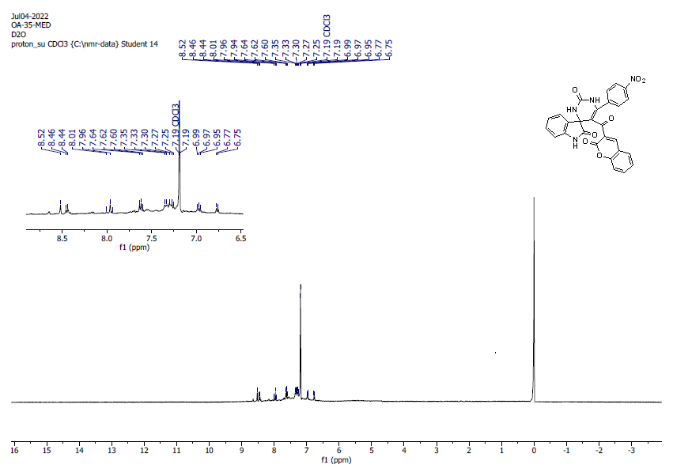

**Fig. 14:** D2O spectrum of compound **5** in CDCl3

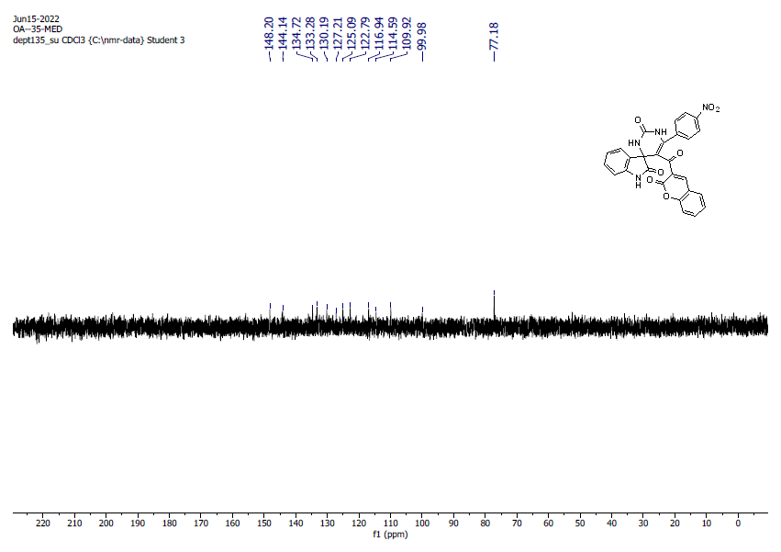

**Fig. 15 :** DEPT 135 spectrum of compound **5** in CDCl3