**Electronic Supplementary Material (ESI) for SJS**

**Supporting Information**

**Synthesis and *in vitro* Antidiabetic Evaluation of Some New Thiazolidinone Derivatives bearing Sulfonamide moiety**

Mounir A. A. Mohamed*, Moshira Helmy Fouad and Ahmed M. M. El-Saghier

**Table of Contents**

**General information**…………………………………………………………………………………………………………………………………………………………………………….S2

**General procedures for synthesis and characterization data of thiazolidinone derivatives** …………………………...S2-S5

**IR and NMR spectra of the obtained thiazolidinone derivatives**……………………………………………………… S6-S40

**Inhibition efficiency of α-amylase enzyme of the synthesized compounds compared to Glitazone**………………………S41

**General information**:

All melting points were determined on a Koﬄer melting point apparatus and are uncorrected. 1H-NMR and 13C NMR spectra were recorded on a Bruker avance 400 MHz spectrometer using TMS as internal reference (chemical shifts in , ppm), and IR spectra were obtained on a Nicolet 710 FT-IR spectrometer (KBr, max in cm-1). Mass spectra were recorded on a GC-MSQP 1000EX Schimadzu at the Microanalytical laboratory, Cairo University, Cairo, Egypt. Elemental analyses were recorded on Vario El Fab-Nr elemental analyzer (Cairo University).

**General procedures for synthesis and characterization data of thiazolidinone derivatives:**

**Synthesis of ethyl 2-(4-methylphenyl-sulfonamido)acetate 1a:**

**Method A:** A round-bottomed flask fitted with a reflux condenser was charged with 4-methylbenzenesulfonyl chloride (4.77 g, 25 mmol), potassium carbonate (4.14 g, 30 mmol) and dimethylsulfoxide (20 mL). The resulting suspension was heated to 50 °C and stirred for 2 hours then the resulting solution was cooled to room temperature and then treated with ethyl glycinate (2.58 mL, 25 mmol) in dimethylsulfoxide (5 mL) added dropwise. The mixture was heated to 50 °C and stirred until TLC showed full consumption of starting material. The mixture was cooled to room temperature, ice cold water (100 mL) added, the organic layer separated, and the aqueous layer extracted with dichloromethane (3 x 50 mL). Thecombined organic layers were washed with a 15 % aqueous solution of potassium hydroxide (100 mL), water (100 mL) and a saturated aqueous solution of sodium chloride (100 mL). The organic layer was dried over magnesium sulfate, filtered and concentrated *in vacuo*.

**Method B:** *p*-Toluenesulfonyl chloride (0.01 mol) was added to glycine (0.02 mol) dissolved in an aqueous solution of potassium carbonate (0.06 mol, 50 mL). The reaction mixture was stirred at 100 ºC for 6 h, then left overnight at room temperature, filtered and then treated with dilute hydrochloric acid. The solid *N*-(4-methylbenzenesulfonyl)glycine obtained was crystallized from aqueous ethanol. Sulfuric acid (0.5 mL) was added to *N*-(4-methylbenzene-sulfonyl)glycine (0.02 mol) dissolved in ethanol (30 mL) and the mixture was heated under reflux for 2-3 hrs. The reaction was monitored by TLC at regular intervals. After completion of the reaction, the reaction mixture was concentrated to remove excess ethanol. The product, *N*-(4-ethylbenzenesulfonyl) glycine ethyl ester **1a** was poured into water, neutralized with sodium bicarbonate and recrystallized from acetone.

**Synthesis of ethyl *N*-(4-methylphenylsulfonamido)-propanoate 1b:**

*p*-Toluenesulfonyl chloride (0.01 mol) was added to -alanine (0.02 mol) dissolved in an aqueous solution of potassium carbonate (0.06 mol, 50 ml). The reaction mixture was stirred at 100 ºC for 6 h, then left overnight at room temperature, filtered and then treated with dilute hydrochloric acid. The solid *N*-(4-methylphenylsulfonamido)propanoic acid obtained was crystallized from aqueous ethanol. Sulfuric acid (0.5 mL) was added to *N*-(4-methylphenylsulfonamido)propanoic acid (0.02 mol) dissolved in ethanol (30 mL) and the mixture was heated under reflux for 2-3 hrs. The reaction was monitored by TLC at regular intervals. After completion of the reaction, the reaction mixture was concentrated to remove excess ethanol. The product, ethyl *N*-(4-methylphenylsulfonamido)-propanoate **1b** was poured into water, neutralized with sodium bicarbonate and recrystallized from acetone.

**2.1.2. Synthesis of *N*-(2-hydrazinyl-2-oxoethyl)-4-methylbenzenesulfonamide 2a,b:**

Compound **1a,b** (10 mmol) was added in small portions to a stirred solution of 85% hydrazine hydrate (3 mL) in 5 mL ethanol. The mixture was heated under reflux for 6 h. While cooling to room temperature, the resulting precipitate was filtered in vacuo, washed with cold water, and dried to give the corresponding hydrazide 2 as a white solid. **2a:** Yield: 84%; m.p. 155–156 ºC; **2b:** Yield: 65%; m.p. 170–172 ºC.

**2.1.3. Synthesis ofv (E)-N-(2-(2-(arylmethylene)hydrazinyl)-2-oxoethyl)-4-methylbenzenesulfonamide 3a-h and (E)-N-(3-(2-(arylmethylene)hydrazinyl)-3-oxopropyl)-4-methylbenzenesulfonamide 4a-h:**

To a magnetically stirred suspension of compound **2a,b** (0.5 mmol) in anhydrous methanol (3 mL) was added the appropriate aldehyde (0.5 mmol). Shortly, the solution became homogeneous and within minutes the resulting hydrazone began to precipitate. After the mixture was stirred for 1–2 h more at room temperature, the precipitate was collected by filtration, washed with a small quantity of cold methanol and dried. Recrystallization of the reaction product from methanol gave the corresponding hydrazone.

**.1.4. Synthesis of 2-(4-methylphenylsulfonamido)-N-(4-oxo-2-aryylthiazolidin-3-yl)acetamide 5a-h and N-(2-aryl-4-oxothiazolidin-3-yl)-3-(4-methylphenylsulfonamido) propanamide 6a-h:**

An equimolar amount (0.01 mol) of the appropriate compound **3a-h** or **4a-h**, ethyl thioglycalate (1.1 mL, 0.01 mol) in ethanol (20 mL) in the presence of pipredine (0.005 mol, 0.5 mL). The mixture was heated under reflux for 5 hours (monitored using a TLC), then poured into ice. The formed solid was collected by filtration and recrystallized from Ethanol.

**2-(4-Methylphenylsulfonamido)-N-(4-oxo-2-phenylthiazolidin-3-yl)acetamide 5a:**

Yield (70%), pale gray crystals, m.p. 238 ºC, Anal. data: (C18H19N3O4S2, 405.08): C, 53.32; H, 4.72; N, 10.36; S, 15.82. Found: C, 53.30; H, 5.09; N, 10.62; S, 15.57%. IR (υmax, cm−1): 3278, 3163 (2NH), 3024 (CHaromatic), 2983 (CHaliphatic), 1742 (C=Othiazolidinone), 1678 (C=O), 1366, 1106 (S=O). 1H-NMR (DMSO-d6), δ ppm: 2.32 (s, 3H, CH3 tosyl), 3.84 (s, 2H, CH2glycine), 4.24 (s, 2H, CH2Thiazolidinone), 5.30 (s, 1H, CH-Ar), 7.24 to 7.75 (m, 9H, ArH), 8.16 (s, 1H, NH, exchangeable by D2O), 9.87 (s, 1H, NH, exchangeable by D2O). 13C NMR (DMSO-d6), δ ppm: 22.1, 36.2, 46.8, 64.7, 126.3, 127.1, 128.3, 128.8, 129.5, 136.5, 136.9, 139.1, 168.4, 170.3.

**2-(4-Methylphenylsulfonamido)-N-(4-oxo-2-p-tolyl-thiazolidin-3-yl)acetamide 5b:**

Yield (78%), pale yellow crystals, m.p. 245 ºC, Anal. data: (C19H21N3O4S2, 419.1): C, 54.40; H, 5.05; N, 10.02; S, 15.29. Found: C, 53.96; H, 4.81; N, 9.68; S, 15.02%. IR (υmax, cm−1): 3270, 3168 (2NH), 3020 (CHaromatic), 2980 (CHaliphatic), 1740 (C=Othiazolidinone), 1675 (C=O), 1365, 1108 (S=O). 1H-NMR (DMSO-d6), δ ppm: 2.30 (s, 3H, CH3tolyl), 2.34 (s, 3H, CH3 tosyl), 3.82 (s, 2H, CH2glycine), 4.20 (s, 2H, CH2Thiazolidinone), 5.34 (s, 1H, CH-Ar), 7.22 to 7.72 (m, 8H, ArH), 8.12 (s, 1H, NH, exchangeable by D2O), 9.85 (s, 1H, NH, exchangeable by D2O). 13C NMR (DMSO-d6), δ ppm: 21.8, 22.1, 36.3, 46.5, 64.6, 126.2, 127.3, 128.2, 128.7, 129.4, 136.6, 136.8, 139.2, 168.6, 170.1.

**N-(2-(4-Chlorophenyl)-4-oxothiazolidin-3-yl)-2-(4-methylphenylsulfonamido)acetamide 5c:**

Yield (86%), yellow needles, m.p. 228 ºC, Anal. data: (C18H18ClN3O4S2, 439.94): C, 49.14; H, Cl, 8.06; 4.12; N, 9.55; S, 15.29. Found: C, 48.86; H, 3.85; Cl, 7.76; N, 9.68; S, 14.58%. IR (υmax, cm−1): 3276, 3162 (2NH), 3025 (CHaromatic), 2982 (CHaliphatic), 1744 (C=Othiazolidinone), 1676 (C=O), 1366, 1112 (S=O). 1H-NMR (DMSO-d6), δ ppm: 2.32 (s, 3H, CH3tosyl), 3.86 (s, 2H, CH2glycine), 4.24 (s, 2H, CH2Thiazolidinone), 5.36 (s, 1H, CH-Ar), 7.28 to 7.77 (m, 8H, ArH), 8.15 (s, 1H, NH, exchangeable by D2O), 9.88 (s, 1H, NH, exchangeable by D2O). 13C NMR (DMSO-d6), δ ppm: 22.1, 36.5, 46.3, 64.2, 126.1, 127.5, 128.1, 128.5, 129.5, 136.7, 136.5, 139.5, 168.7, 170.5.

N**-(2-(4-(Dimethylamino)phenyl)-4-oxothiazolidin-3-yl)-2-(4-methylphenylsulfonamido)acetamide 5d:**

Yield (80%), bright yellow needles, m.p. 212 ºC, Anal. data: (C20H24N4O4S2, 448.56): C, 53.55; H, 5.39; N, 12.49; S, 14.30. Found: C, 53.05; H, 9.01; N, 12.20; S, 14.18%. IR (υmax, cm−1): 3266, 3172 (2NH), 3034 (CHaromatic), 2976 (CHaliphatic), 1752 (C=Othiazolidinone), 1670 (C=O), 1369, 1111 (S=O). 1H-NMR (DMSO-d6), δ ppm: 2.34 (s, 3H, CH3tolyl), 3.04 (s, 6H, 2CH3), 3.82 (s, 2H, CH2glycine), 4.21 (s, 2H, CH2Thiazolidinone), 5.37 (s, 1H, CH-Ar), 6.98 to 7.74 (m, 8H, ArH), 8.14 (s, 1H, NH, exchangeable by D2O), 9.80 (s, 1H, NH, exchangeable by D2O). 13C NMR (DMSO-d6), δ ppm: 21.2, 35.8, 41.2, 46.8, 64.4, 126.2, 127.4, 128.3, 128.4, 129.4, 136.8, 136.0, 139.1, 168.5, 170.3. MS: m/z: 448.12 (100.0).

**2-(4-Methylphenylsulfonamido)-N-(2-(naphthalen-1-yl)-4-oxothiazolidin-3-yl)acetamide 5e:**

Yield (70%), gray crystals, m.p. 256 ºC, Anal. data: (C22H21N3O4S2, 455.55): C, 58.00; H, 4.65; N, 9.22; S, 14.08. Found: C, 57.76; H, 4.24; N, 8.90; S, 13.78%. IR (υmax, cm−1): 3270, 3165 (2NH), 3028 (CHaromatic), 2981 (CHaliphatic), 1745 (C=Othiazolidinone), 1672 (C=O), 1362, 1102 (S=O). 1H-NMR (DMSO-d6), δ ppm: 2.34 (s, 3H, CH3 tosyl), 3.84 (s, 2H, CH2glycine), 4.22 (s, 2H, CH2Thiazolidinone), 5.35 (s, 1H, CH-Ar), 7.18-7.78 (m, 11H, ArH), 8.15 (s, 1H, NH, exchangeable by D2O), 9.87 (s, 1H, NH, exchangeable by D2O). 13C NMR (DMSO-d6), δ ppm: 21.3, 35.3, 46.8, 62.7, 126.3, 126.8, 127.1, 127.6, 128.3, 128.8, 129.2, 129.8, 136.2, 136.5, 136.9, 138.8, 139.1, 139.8, 168.0, 170.1. MS: m/z: 455.10 (100.0%).

**N-(2-(3-Hydroxyphenyl)-4-oxothiazolidin-3-yl)-2-(4-methylphenylsulfonamido)acetamide 5f:**

Yield (76%), yellow needles, m.p. 232 ºC, Anal. data: (C18H19N3O5S2, 421.49): C, 51.29; H, 4.54; N, 9.97; S, 15.22. Found: C, 51.01; H, 4.23; N, 9.61; S, 14.98%. IR (υmax, cm−1): 3442 (OH), 3278, 3172 (2NH), 3018 (CHaromatic), 2985 (CHaliphatic), 1748 (C=Othiazolidinone), 1678 (C=O), 1364, 1114 (S=O). 1H-NMR (DMSO-d6), δ ppm: 2.32 (s, 3H, CH3tosyl), 3.88 (s, 2H, CH2glycine), 4.22 (s, 2H, CH2Thiazolidinone), 5.34 (s, 1H, CH-Ar), 7.28-7.70 (m, 8H, ArH), 8.12 (s, 1H, NH, exchangeable by D2O), 9.88 (s, 1H, NH, exchangeable by D2O), 11.86 (br, 1H, 0H, exchangeable by D2O). 13C NMR (DMSO-d6), δ ppm: 22.3, 36.6, 46.6, 64.5, 126.1, 127.5, 128.1, 128.5, 129.5, 136.0, 136.5, 139.5, 168.6, 170.6.

**2-(4-Methylphenylsulfonamido)-N-(2-(3-nitrophenyl)-4-oxothiazolidin-3-yl)acetamide 5g:**

Yield (70%), yellow crystals, m.p. 268 ºC, Anal. data: (C18H18N4O6S2, 450.49): C, 47.99; H, 4.03; N, 12.44; S, 14.24. Found: C, 47.69; H, 3.82; N, 12.08; S, 14.00%. IR (υmax, cm−1): 3286, 3180 (2NH), 3027 (CHaromatic), 2975 (CHaliphatic), 1745 (C=Othiazolidinone), 1674 (C=O), 1366, 1118 (S=O). 1H-NMR (DMSO-d6), δ ppm: 2.34 (s, 3H, CH3tosyl), 3.87 (s, 2H, CH2glycine), 4.24 (s, 2H, CH2Thiazolidinone), 5.36 (s, 1H, CH-Ar), 7.28-7.78 (m, 8H, ArH), 8.10 (s, 1H, NH, exchangeable by D2O), 9.88 (s, 1H, NH, exchangeable by D2O. 13C NMR (DMSO-d6), δ ppm: 22.2, 36.5, 46.3, 64.7, 126.2, 127.1, 128.1, 128.8, 129.5, 136.1, 136.8, 139.5, 168.6, 170.6. MS: m/z: 450.07 (100.0%).

**(E)-2-(4-Methylphenylsulfonamido)-N-(4-oxo-2-styrylthiazolidin-3-yl)acetamide 5h:**

Yield (75%), pale yellow crystals, m.p. 266 ºC, Anal. data: (C20H21N3O4S2, 431.53): C, 55.67; H, 4.91; N, 9.74; S, 14.86. Found: C, 55.40; H, 4.76; N, 9.48; S, 14.60%. IR (υmax, cm−1): 3270, 3168 (2NH), 3028, 3012 (CHaromatic), 2982 (CHaliphatic), 1745 (C=Othiazolidinone), 1678 (C=O), 1366, 1112 (S=O). 1H-NMR (DMSO-d6), δ ppm: 2.34 (s, 3H, CH3tosyl), 3.86 (s, 2H, CH2glycine), 4.24 (s, 2H, CH2Thiazolidinone), 5.37 (s, 1H, CH-Ar), 6.19 (m, 1H, CHolefinic), 6.26 (d, 1H, CH2Thiazolidinone), 7.18 to 7.75 (m, 9H, ArH), 8.10 (s, 1H, NH, exchangeable by D2O), 9.88 (s, 1H, NH, exchangeable by D2O). 13C NMR (DMSO-d6), δ ppm: 21.8, 22.1, 36.3, 46.5, 64.6, 121.2, 123.5, 126.1, 127.4, 128.2, 128.6, 129.4, 136.1, 136.6, 139.4, 168.5, 170.4. MS: m/z: 431.10 (100.0%).

**3-(4-Methylphenylsulfonamido)-N-(4-oxo-2-phenylthiazolidin-3-yl)propanamide 6a:**

Yield (75%), yellow needles, m.p. 246 ºC, Anal. data: (C19H21N3O4S2, 419.52): C, 54.40; H, 5.05; N, 10.02; S, 15.29. Found: C, 54.16; H, 4.83; N, 9.91; S, 14.98%. IR (υmax, cm−1): 3271, 3175 (2NH), 3012 (CHaromatic), 2980 (CHaliphatic), 1743 (C=Othiazolidinone), 1670 (C=O), 1365, 1114 (S=O). 1H-NMR (DMSO-d6), δ ppm: 2.32 (s, 3H, CH3tosyl), 2.42 (t, 2H, CH2alanine), 3.88 (s, 2H, CH2alanine), 4.24 (s, 2H, CH2Thiazolidinone), 5.35 (s, 1H, CH-Ar), 7.25-7.77 (m, 9H, ArH), 8.15 (s, 1H, NH, exchangeable by D2O), 9.85 (s, 1H, NH, exchangeable by D2O). 13C NMR (DMSO-d6), δ ppm: 22.3, 36.2, 37.3, 46.5, 64.5, 126.1, 127.5, 128.1, 128.5, 129.5, 136.0, 136.5, 139.5, 168.6, 170.6. MS: m/z: M+1 420 (11.0%).

**3-(4-Methylphenylsulfonamido)-N-(4-oxo-2-p-tolylthiazolidin-3-yl)propanamide 6b:**

Yield (77%), pale yellow needles, m.p. 255 ºC, Anal. data: (C20H23N3O4S2, 433.54): C, 55.41; H, 5.35; N, 9.69; S, 14.79. Found: C, 55.16; H, 5.03; N, 9.38; S, 14.44%. IR (υmax, cm−1): 3278, 3177 (2NH), 3018 (CHaromatic), 2985 (CHaliphatic), 1748 (C=Othiazolidinone), 1676 (C=O), 1368, 1116 (S=O). 1H-NMR (DMSO-d6), δ ppm: 2.30 (s, 3H, CH3tosyl), 2.34 (s, 3H, CH3tolyl), 2.40 (t, 2H, CH2alanine), 3.86 (s, 2H, CH2alanine), 4.20 (s, 2H, CH2Thiazolidinone), 5.33 (s, 1H, CH-Ar), 7.22-7.70 (m, 8H, ArH), 8.12 (s, 1H, NH, exchangeable by D2O), 9.83 (s, 1H, NH, exchangeable by D2O). 13C NMR (DMSO-d6), δ ppm: 22.3, 36.1, 36.8, 37.7, 46.1, 64.8, 126.1, 127.3, 128.2, 128.6, 129.8, 136.1, 136.6, 139.7, 168.2, 170.4. MS: m/z: M+1435 (4.0%).

**N-(2-(4-Chlorophenyl)-4-oxothiazolidin-3-yl)-3-(4-methylphenylsulfonamido)propanamide 6c:**

Yield (82%), yellow needles, m.p. 248 ºC, Anal. data: (C19H20ClN3O4S2, 453.96): C, 50.27; H, 4.44; Cl, 7.81, N, 9.26; S, 14.13. Found: C, 50.05; H, 4.13; Cl, 7.55, N, 9.02; S, 13.87%. IR (υmax, cm−1): 3277, 3170 (2NH), 3025 (CHaromatic), 2981 (CHaliphatic), 1745 (C=Othiazolidinone), 1677 (C=O), 1365, 1111 (S=O). 1H-NMR (DMSO-d6), δ ppm: 2.32 (s, 3H, CH3tosyl), 2.41 (t, 2H, CH2alanine), 3.88 (s, 2H, CH2alanine), 4.24 (s, 2H, CH2Thiazolidinone), 5.35 (s, 1H, CH-Ar), 7.28-7.75 (m, 8H, ArH), 8.16 (s, 1H, NH, exchangeable by D2O), 9.85 (s, 1H, NH, exchangeable by D2O). 13C NMR (DMSO-d6), δ ppm: 22.3, 36.1, 36.8, 37.7, 46.1, 64.8, 126.1, 127.3, 128.2, 128.6, 129.8, 136.1, 136.6, 139.7, 168.2, 170.4. MS: m/z: M+2455 (12.0%).

**N-(2-(4-(Dimethylamino)phenyl)-4-oxothiazolidin-3-yl)-3-(4-methylphenylsulfonamido)propanamide 6d:**

Yield (82%), yellow needles, m.p. 248 ºC, Anal. data: (C21H26N4O4S2, 462.59): C, 54.52; H, 5.67; N, 12.11; S, 13.86. Found: C, 54.22; H, 5.33; N, 11.85; S, 13.57%. IR (υmax, cm−1): 3278, 3172 (2NH), 3022 (CHaromatic), 2984 (CHaliphatic), 1748 (C=Othiazolidinone), 1675 (C=O), 1362, 1113 (S=O). 1H-NMR (DMSO-d6), δ ppm: 2.32 (s, 3H, CH3tosyl), 2.41 (t, 2H, CH2alanine), 3.06 (s, 6H, 2CH3), 3.86 (s, 2H, CH2alanine), 4.22 (s, 2H, CH2Thiazolidinone), 5.36 (s, 1H, CH-Ar), 7.25-7.77 (m, 8H, ArH), 8.15 (s, 1H, NH, exchangeable by D2O), 9.84 (s, 1H, NH, exchangeable by D2O). 13C NMR (DMSO-d6), δ ppm: 22.3, 36.1, 36.8, 37.7, 46.1, 64.8, 126.1, 127.3, 128.2, 128.6, 129.8, 136.1, 136.6, 139.7, 168.2, 170.4. MS: m/z: M+1462 (5.8%).

**3-(4-Methylphenylsulfonamido)-N-(2-(naphthalen-1-yl)-4-oxothiazolidin-3-yl)propanamide 6e:**

Yield (75%), yellow needles, m.p. 218 ºC, Anal. data: (C23H23N3O4S2, 469.58): C, 58.83; H, 4.94; N, 8.95; S, 13.66. Found: C, 58.46; H, 4.66; N, 8.60; S, 13.35%. IR (υmax, cm−1): 3275, 3162 (2NH), 3025 (CHaromatic), 2982 (CHaliphatic), 1748 (C=Othiazolidinone), 1678 (C=O), 1366, 1118 (S=O). 1H-NMR (DMSO-d6), δ ppm: 2.34 (s, 3H, CH3tosyl), 2.40 (t, 2H, CH2alanine), 3.86 (s, 2H, CH2alanine), 4.22 (s, 2H, CH2Thiazolidinone), 5.36 (s, 1H, CH-Ar), 7.18-7.78 (m, 11H, ArH), 8.10 (s, 1H, NH, exchangeable by D2O), 9.88 (s, 1H, NH, exchangeable by D2O). 13C NMR (DMSO-d6), δ ppm: 22.3, 36.2, 37.3, 46.5, 64.5, 125.6, 126.1, 126.8, 127.5, 128.1, 128.5, 129.3, 129.8, 136.0, 136.5, 137.2, 137.8, 139.1, 139.5, 168.0, 170.3. MS: m/z: M+1 470 (7.0%).

**N-(2-(3-Hydroxyphenyl)-4-oxothiazolidin-3-yl)-3-(4-methylphenylsulfonamido)propanamide 6f:**

Yield (78%), yellow needles, m.p. 232 ºC, Anal. data: (C19H21N3O5S2, 435.52): C, 52.40; H, 4.86; N, 9.65; S, 14.73. Found: C, 52.15; H, 4.53; N, 9.41; S, 14.48%. IR (υmax, cm−1): 3445 (OH), 3273, 3166 (2NH), 3020 (CHaromatic), 2981 (CHaliphatic), 1746 (C=Othiazolidinone), 1675 (C=O), 1366, 1115 (S=O). 1H-NMR (DMSO-d6), δ ppm: 2.34 (s, 3H, CH3tosyl), 3.88 (s, 2H, CH2alanine), 3.86 (s, 2H, CH2alanine), m4.24 (s, 2H, CH2Thiazolidinone), 5.35 (s, 1H, CH-Ar), 7.28-7.72 (m, 8H, ArH), 8.15 (s, 1H, NH, exchangeable by D2O), 9.86 (s, 1H, NH, exchangeable by D2O), 11.88 (br, 1H, 0H, exchangeable by D2O). 13C NMR (DMSO-d6), δ ppm: 22.1, 36.5, 37.3, 46.5, 64.5, 126.1, 127.4, 128.2, 128.5, 129.4, 1361, 136.3, 139.4, 168.5, 170.4.

**3-(4-Methylphenylsulfonamido)-N-(2-(3-nitrophenyl)-4-oxothiazolidin-3-yl)propanamide 6g:**

Yield (70%), yellow crystals, m.p. 272 ºC, Anal. data: (C19H20N4O6S2, 464.52): C, 49.13; H, 4.34; N, 12.06; S, 13.81. Found: C, 48.89; H, 3.22; N, 11.88; S, 13.55%. IR (υmax, cm−1): 3288, 3185 (2NH), 3027 (CHaromatic), 2977 (CHaliphatic), 1748 (C=Othiazolidinone), 1678 (C=O), 1366, 1115 (S=O). 1H-NMR (DMSO-d6), δ ppm: 2.34 (s, 3H, CH3tosyl), 3.87 (s, 2H, CH2alanine), 3.86 (s, 2H, CH2alanine), 4.24 (s, 2H, CH2Thiazolidinone), 5.35 (s, 1H, CH-Ar), 7.28-7.78 (m, 8H, ArH), 8.10 (s, 1H, NH, exchangeable by D2O), 9.88 (s, 1H, NH, exchangeable by D2O. 13C NMR (DMSO-d6), δ ppm: 22.2, 36.5, 37.3, 46.3, 64.7, 126.2, 127.1, 128.1, 128.8, 129.5, 136.1, 136.8, 139.5, 168.6, 170.6. MS: m/z: M+1465.07 (100.0%).

**(E)-3-(4-Methylphenylsulfonamido)-N-(4-oxo-2-styrylthiazolidin-3-yl)propanamide 6h:**

Yield (70%), pale yellow crystals, m.p. 262 ºC, Anal. data: (C21H23N3O4S2, 445.56): C, 56.61; H, 5.20; N, 9.43; S, 14.39. Found: C, 56.40; H, 4.96; N, 9.25; S, 14.00%. IR (υmax, cm−1): 3274, 3166 (2NH), 3025, 3022 (CHaromatic), 2980 (CHaliphatic), 1748 (C=Othiazolidinone), 1675 (C=O), 1368, 1116 (S=O). 1H-NMR (DMSO-d6), δ ppm: 2.34 (s, 3H, CH3tosyl), 3.86 (s, 2H, CH2alanine), 3.86 (s, 2H, CH2alanine), 4.24 (s, 2H, CH2Thiazolidinone), 5.37 (s, 1H, CH-Ar), 6.19 (m, 1H, CHolefinic), 6.26 (d, 1H, CH2Thiazolidinone), 7.18 to 7.75 (m, 9H, ArH), 8.10 (s, 1H, NH, exchangeable by D2O), 9.88 (s, 1H, NH, exchangeable by D2O). 13C NMR (DMSO- d6), δ ppm: 21.8, 22.1, 36.3, 37.2, 46.5, 64.6, 121.2, 123.5, 126.1, 127.4, 128.2, 128.6, 129.4, 136.1, 136.6, 139.4, 168.5, 170.4. MS: m/z: M+1465.10 (8.0%).

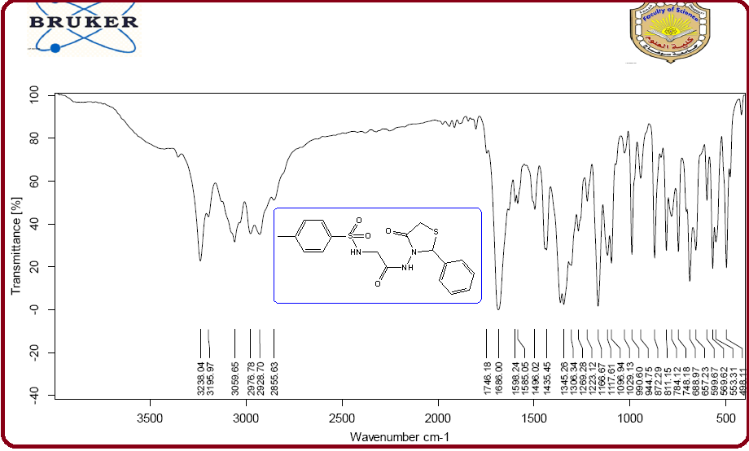

IR Spectrum of compound **5a**

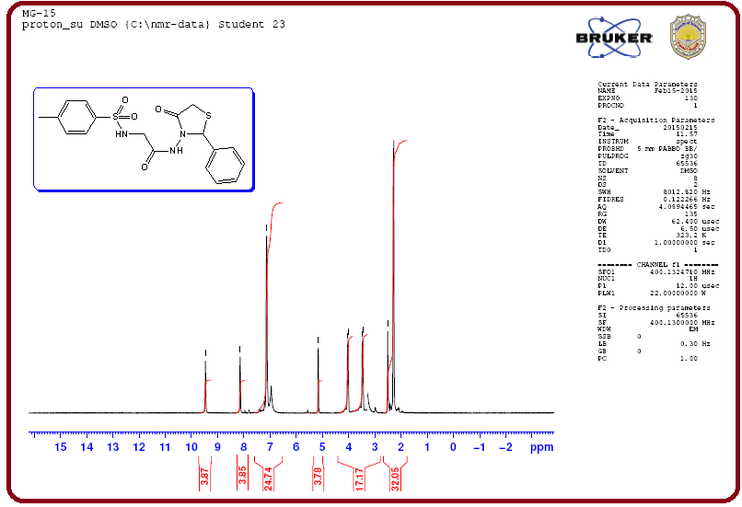

1H-NMR Spectrum of compound **5a**

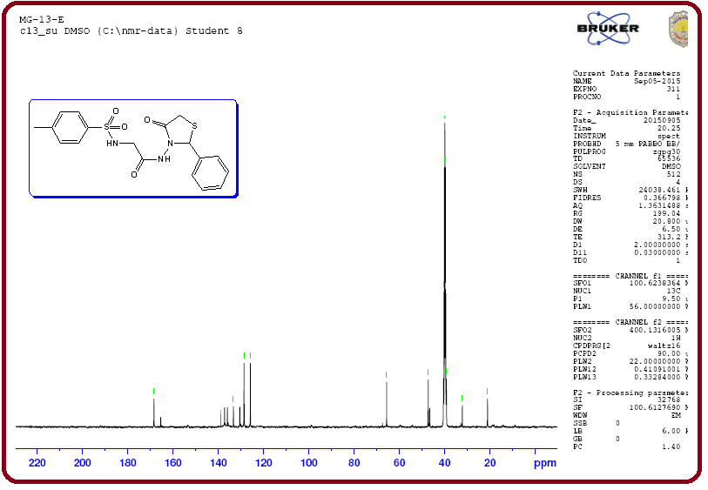

13CMR Spectrum of compound **5a**

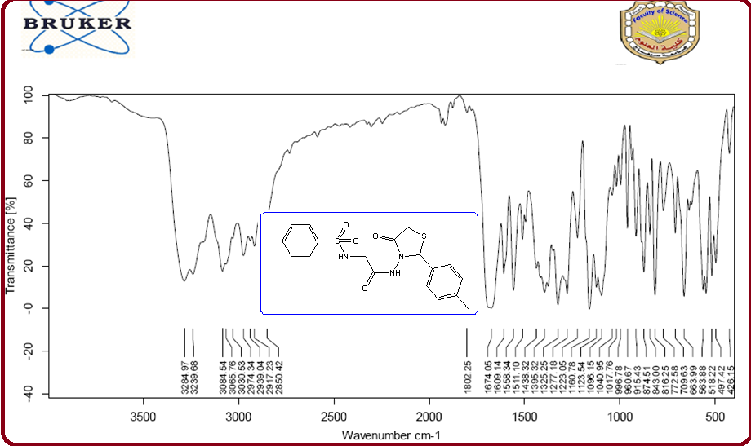

IR Spectrum of compound **5b**

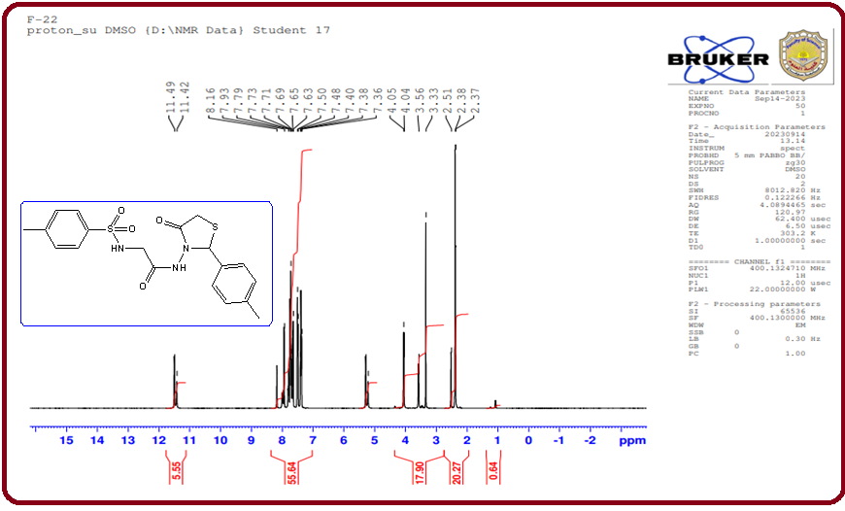

1H-NMR Spectrum of compound **5b**

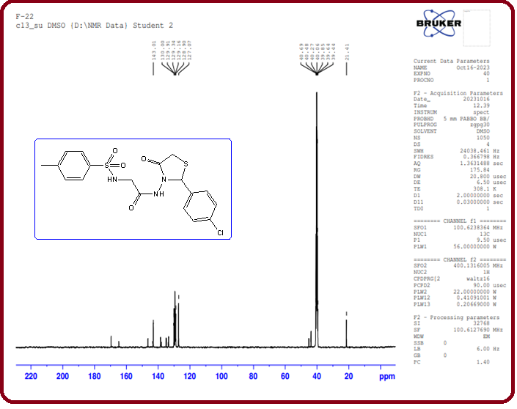

13CMR Spectrum of compound **5c**

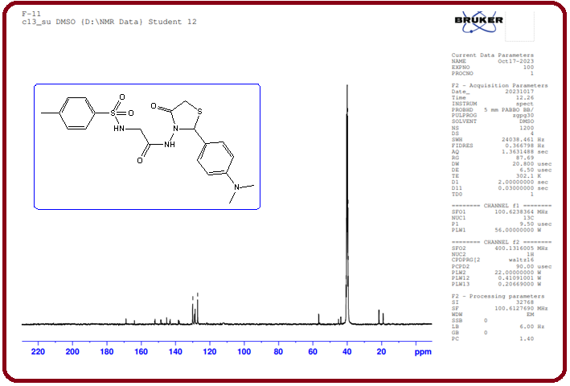

13CMR Spectrum of compound **5d**

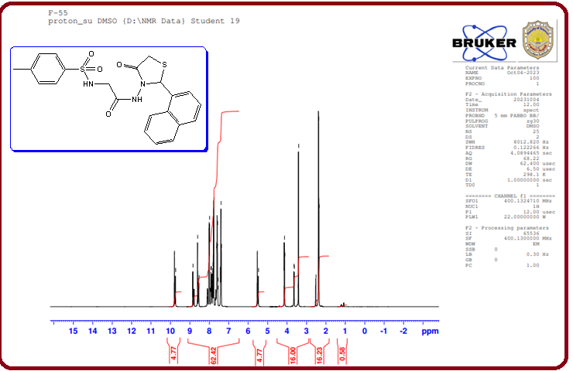

1H-NMR Spectrum of compound **5e**

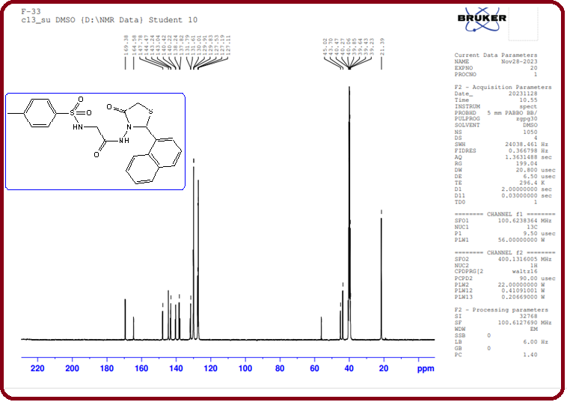

13CMR Spectrum of compound **5e**

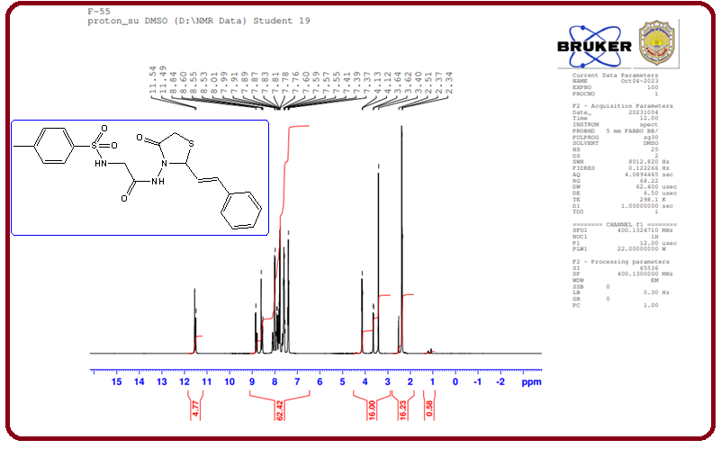

1H-NMR Spectrum of compound **5h**

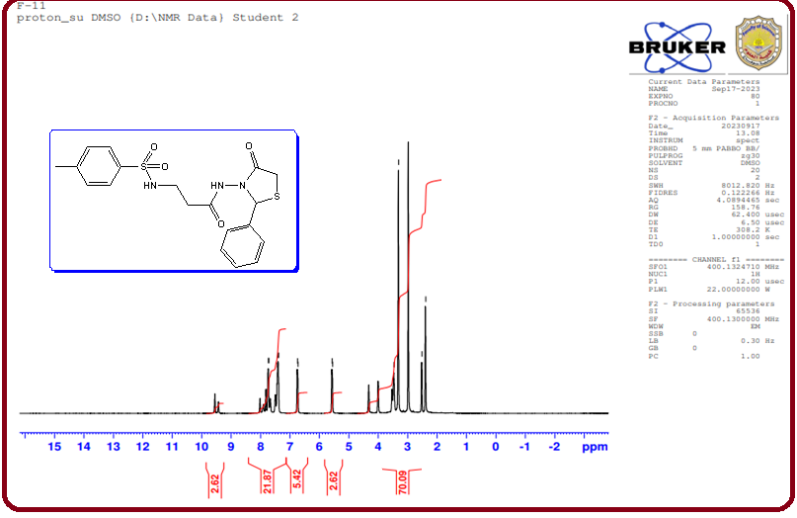

1H-NMR Spectrum of compound **6a**

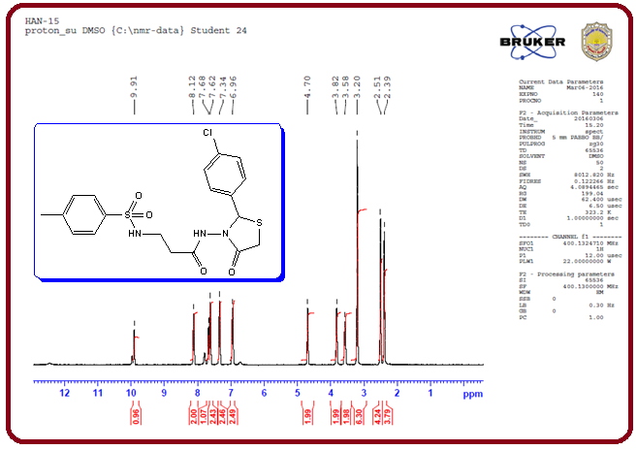

1H-NMR Spectrum of compound **6c**

**Table 1: Effect of Some Thiazolidinone Derivatives (TZDs) on Glucose Diffusion.**

|  |  |  |  |  |  |
| --- | --- | --- | --- | --- | --- |
| **Compound** | **Absorbance** | | | | |
| **6.25 mg/dL** | **12.5 mg/dL** | **25 mg/dL** | **50 mg/dL** | **100 mg/dL** |
| **Glitazone** | 0.258 | 0.315 | 0.376 | 0.420 | 0.488 |
| **5a** | 0.200 | 0.288 | 0.360 | 0.390 | 0.421 |
| **5b** | 0.229 | 0.260 | 0.345 | 0.426 | 0.468 |
| **5c** | 0.203 | 0.255 | 0.320 | 0.387 | 0.478 |
| **5d** | 0.170 | 0.205 | 0.243 | 0.295 | 0.366 |
| **5e** | 0.210 | 0.252 | 0.334 | 0.415 | 0.455 |
| **5f** | 0.225 | 0.275 | 0.355 | 0.432 | 0.480 |
| **5g** | 0.205 | 0.260 | 0.348 | 0.422 | 0.467 |
| **5h** | 0.225 | 0.263 | 0.341 | 0.429 | 0.470 |
| **6b** | 0.134 | 0.189 | 0.239 | 0.288 | 0.345 |
| **6c** | 0.108 | 0.156 | 0.202 | 0.239 | 0.267 |
| **6d** | 0.129 | 0.188 | 0.225 | 0.271 | 0.340 |
| **6e** | 0.125 | 0.175 | 0.202 | 0.255 | 0.303 |

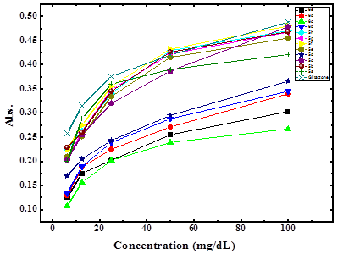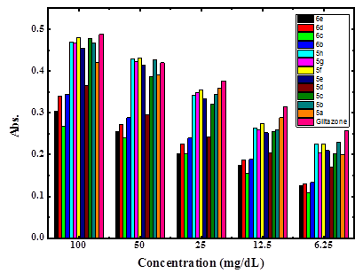

Fig. 2: Inhibition efficiency of α-amylase enzyme of the synthesized compounds compared to glitazone