Supplementary Materials
Optimizing Ciprofloxacin Detection: Spectrophotometric Method Validation Across Chemical and Thermal Parameters
Lobna A. E. Nassr ª, Yathreb A. Khalifa ^{a,*}, Ali M. Shaker ª , Ibrahim M. A. Mohamed ª
ª Department of Chemistry, Faculty of Science, Sohag University, Sohag 82524, Egypt
* Corresponding author: Email: * yathreb123450@gmail.com.

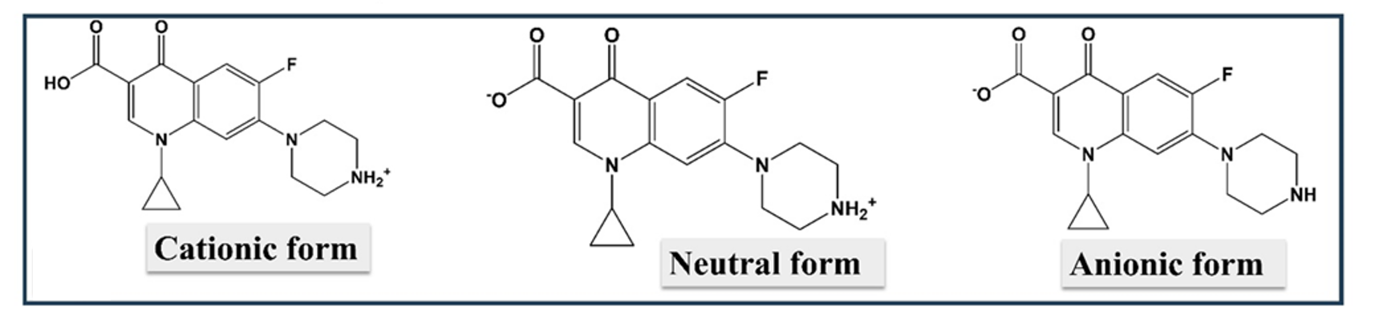

Fig. S1. CIP cationic, neutral, and anionic forms.

Table S1. Features of the calibration curve for CIP determined by spectrophotometric method:
Parameters of regression lines | values
Beer's law limit (µg/ml) | 5-30
Regression coefficient (r²) | 0.99
Molar absorptivity (10⁴ L mol⁻¹ cm⁻¹) | 2.26
Linearity equationª | y = 0.0588x+0.1185
LOD^{b} (µg/ml) | 5.73
LOQ^{c} (µg/ml) | 17.38
Mean recovery (%) | 99.2
ª y refers to absorbance; x refers to concentration in µg/ml
^{b} Limit of detection
^{C} Limit of quantification

Table S2. Assay data of ciprofloxacin at different pH.
Variable Parameter | concentration range  (µgml⁻¹) | Found concentration (µg ml⁻¹) | Linearity eq. | Molar absorptivity (10⁴ L.mol⁻¹.cm⁻¹ )
pH = 2 | 3-15 | 2.9-15.6 | Y = 0.0694 X + 0.0826 | 2.68
pH = 3 | 3-15 | 2.6-15.1 | Y = 0.0599 X + 0.1533 | 2.31
pH = 4 | 3-15 | 2.7-15.3 | Y = 0.0633 X + 0.1378 | 2.44
pH = 5 | 3-15 | 2.9-16.2 | Y = 0.058 X + 0.1383 | 2.24
pH = 6 | 3-15 | 3.2-15.6 | Y = 0.0569 X + 0.1157 | 2.2
pH = 8 | 3-15 | 3.2-14.9 | Y = 0.0501 X + 0.2185 | 1.93
pH = 10 | 3-15 | 3.5-15.7 | Y = 0.0542 X + 0.1806 | 2.09
pH = 11 | 3-15 | 2.7-15 | Y = 0.0533 X + 0.1738 | 2.06
pH = 12 | 3-15 | 2.4-15.3 | Y = 0.0518 X + 0.1737 | 1.99

Table S3. LOD, LOQ, recovery (%), and mean recovery data of ciprofloxacin at different pH values
Variable Parameter | LOD | LOQ | Recovery (%) | Mean recovery
pH = 2 | 5.00 | 15.2 | 96.9-104.4 | 100.30
pH = 3 | 6.10 | 18.6 | 87.6-100.7 | 99.80
pH = 4 | 4.50 | 13.5 | 90.23-102.3 | 99.90
pH = 5 | 9.30 | 28.2 | 98.1-107.9 | 100.60
pH = 6 | 3.40 | 10.3 | 107.9-103.7 | 100.00
pH = 8 | 3.80 | 11.5 | 106.8-99.6 | 100.20
pH = 10 | 5.40 | 16.4 | 117.2-101.2 | 101.20
pH = 11 | 3.20 | 9.7 | 89.2-100.1 | 99.70
pH = 12 | 5.02 | 15.2 | 81.1-102.1 | 98.90

Table S4. Assay data of ciprofloxacin at different ionic strength values
Variable Parameter | concentration range (µg ml⁻¹) | Found concentration | Linearity eq. | Molar absorptivity (10⁴ L.mol⁻¹.cm⁻¹ )
I = 0.05 | (3-15 µg/ml ) | 2.7-15 | y = 0.0622x + 0.154 | 2.4
I = 0.1 | (3-15 µg/ml ) | 2.7-14.9 | y = 0.0599x + 0.146 | 2.31
I = 0.2 | (3-15 µg/ml ) | 3.3-14.9 | y = 0.0589x + 0.1713 | 2.27
I = 0.3 | (3-15 µg/ml ) | 2.8-15.1 | y = 0.0627x + 0.1543 | 2.42
I = 0.5 | (3-15 µg/ml ) | 3.3-15.02 | y = 0.0631x + 0.1435 | 2.43

Table S5. LOD, LOQ, recovery (%), and mean recovery data of ciprofloxacin at different ionic strength values
Variable Parameter | LOD | LOQ | Recovery(%) | Mean recovery
I = 0.05 M | 5.2 | 15.7 | 89.01-99.9 | 99.7
I = 0.1 M | 1.7 | 5.2 | 91.3-99.4 | 99.6
I = 0.2 M | 3.9 | 11.8 | 111.3-99.5 | 100.9
I = 0.3 M | 4.3 | 13.2 | 93.8-100.9 | 100.03
I = 0.5 M | 4.3 | 13 | 109.2-100.1 | 100.5

Table S6. Assay data of ciprofloxacin at different temperature values
Variable Parameter | concentration range (µg ml⁻¹) | Found concentration | Linearity eq. | Molar absorptivity (10⁴ L mol⁻¹ cm⁻¹)
T = 283 K | 3-15 | 2.6-16.3 | y = 0.0562x + 0.1275 | 2.17
T = 293 K | 3-15 | 2.9-14.6 | y = 0.0494x + 0.2425 | 1.91
T = 303 K | 3-15 | 3.1-15.9 | y = 0.0565x + 0.1799 | 2.18
T = 403 K | 3-15 | 3.8-16.3 | y = 0.0579x + 0.1868 | 2.23

Table S7. LOD, LOQ, recovery (%), and mean recovery data of ciprofloxacin at different temperature values
Variable Parameter | LOD | LOQ | Recovery(%) | Mean recovery
T = 283 K | 9.4 | 28.4 | 87.01-108.5 | 99.4
T = 293 K | 9.3 | 28.2 | 95.9-97.6 | 100.05
T = 303 K | 8.2 | 24.7 | 103.3-106.2 | 101.2
T = 403 K | 7.9 | 23.8 | 126.8-108.5 | 101.9

