**One-pot Multicomponent Synthesis of Novel Polyfunctionalized Pyridines**

Hayam H. Mohammed, Eman A. Ahmed Bahgat R. M. Hussein*, and Omran A. Omran

*Chemistry Department, Faculty of Science, Sohag University, Sohag 82524, Egypt*

*\*Email:* [*bahgat.ramadan@yahoo.com*](mailto:bahgat.ramadan@yahoo.com) & *bahgat@science.sohag.edu.eg*

**­**

**General procedure for synthesis of 2-[4-(2,2-dicyanovinyl)-2-methoxyphenoxy]-*N*-phenylacetamide (3)**:

In 20 mL of ethanol, a combination of compound 1 (0.5 g, 2 mmol) and malononitrile 2 (0.12 g, 2 mmol) was refluxed for 1 hour with a few drops triethylamine (TEA). The produced precipitate was filtered out on hot, rinsed several times with cold ethanol, and crystallised from acetonitrile.

Yellow powder, yield: 0.54 g (92%), mp. 234-236 oC; IR (ATR) * * max: 3377 (NH), 3040 (CHarom.), 2924, 2837 (CHaliph.), 2216 (CN), 1683 (C=Oamidic) cm-1; 1H NMR *δ:* 10.24 (s, 1H, NH ), 8.40 (s, 1H, CHolefinic), 7.70 (s, 1H, CHarom.), 7.63-7.59 (m, 3H,CHarom.), 7.36-7.32 (t, 2H, *J* = 8 Hz, CHarom.), 7.19, 7.17 (d, 1H, *J* = 8 Hz, CHarom), 7.11-7.08 (t, 1H, *J* = 6 Hz, CHarom. ), 4.92 (s, 2H, CH2), 3.86 (s, 3H, OCH3). *Anal*. Calcd. for C19H15N3O3 (333.34): C, 68.46; H, 4.54; N, 12.61%. Found: C, 68.54; H, 4.32; N, 12.75%.

**General procedure for synthesis of pyridines 6a-f:**

To a solution of arylidene **3** (0.5 g, 1 mmol) in 30 mL of ethanol was mixed with sodium ethoxide **5** (0.14 g, 2 mmol)), and 1 mmol of respective methylarylketones **4a-f** namely; acetophenone (0.12 g, 1 mmol), 4-chloroacetophenone (0.15 g, 1 mmol), 4-methoxyacetophenone (0.15 g, 1 mmol), 3-acetylpyidine (0.12 g, 1 mmol), 2-acetylthiophene (0.13 g, 1 mmol) and/or 2-acetylnaphthalene (0.17 g, 1 mmol) was added. The reaction mixture was refluxed and monitored using TLC for around 5 hours before being allowed to cool to room temperature then put into 30 mL of ice cold water. The precipitate was filtered, rinsed multiple times with water, dried, and crystallised from ethanol.

**2-(4-(3-Cyano-2-ethoxy-6-phenylpyridin-4-yl)-2-methoxy-phenoxy)-*N*-phenyl acetamide (6a):**



Pale yellow powder, yield: 0.58g (80%), mp. 203-205 oC; FT-IR (ATR) * max*: 3423 (NH), 3051 (CHarom.), 2977, 2918, 2847 (CHaliph.), 2212 (CN), 1692 (C=Oamide) cm-1; 1H NMR: *δ* 8.24, 8.23 (d, 2H, *J* = 4 Hz, CHarom.), 7.78 (s, 1H,CHarom.), 7.62-7.54 (m, 4H, CHarom.), 7.43 (s, 1H, NH.), 7.31-7.24 (m, 6H, CHarom.), 6.96 (s, 1H, CHarom.), 4.67-4.64 (q, 2H, *J* = 7 Hz, O**CH2**CH3), 3.97 (s, 3H, OCH3), 3.38 (s, 2H, O**CH2**CO), 1.47-1.45 (t, 3H, *J* = 7 Hz, OCH2**CH3**).*Anal*.Calcd. for C29H25N3O4 (479.5): C, 72.64; H, 5.25; N, 8.76%. Found: C, 72.52; H, 5.44; N, 8.66%.

**2-(4-(6-(4-Chlorophenyl)-3-cyano-2-ethoxypyridin-4-yl)-2-methoxyphenoxy)-**

***N*-phenylacetamide (6b):**



Pale yellow powder, yield: 0.59g (77%), mp.198-200oC; FT-IR (ATR) * max*:3421 (NH), 3055 (CHarom.), 2975, 2920, 2829 (CHaliph.), 2211 (CN), 1633 (C=Oamide) cm-1; 1H NMR: *δ* 8.29,8.27 (d, 2H, CHarom.), 7.82 (s, 1H,CHarom.), 7.67 (s, 1H, CHarom.), 7.62, 7.60 (d, 2H, *J* = 8 Hz, CHarom.), 7.44 (s, 1H, NH), 7.32-7.29 (m, 4H,CHarom.), 7.24-7.22 (m, 2H, *J* = 8 Hz, CHarom.), 6.97-6.94 (t, 1H, *J* = 7 Hz,CHarom.), 4.67-4.62 (q, 2H, *J* = 7 Hz, O**CH2**CH3), 3.97 (s, 3H, OCH3) 3.36 (s, 2H, O**CH2**CO), 1.47-1.44 (t, 3H, *J* = 7 Hz, OCH2**CH3**). 13C NMR: *δ* 164.71, 156.81, 156.13, 155.96, 148.60, 148.51, 142.35, 136.15, 135.85, 135.77, 129.61, 129.36, 126.26, 122.17, 121.85, 119.68, 116.42 (CN), 113.91, 113.48, 111.89, 90.86, 63.56, 61.90, 56.31, 14.77, Dept-135 NMR: *δ* 129.60, 129.56, 129.35, 122.17, 121.84, 119.68, 113.91, 113.48, 111.89, 63.55 (O**CH2**CH3), 61.90 (O**CH2**CO), 56.30 (OCH3), 14.77 (OCH2**CH3**). *Anal*. Calcd. for C29H24ClN3O4 (513.97): C, 67.77; H, 4.71; N, 8.18%. Found: C, 67.60; H, 4.81; N, 8.08%.

**2-(4-(3-Cyano-2-ethoxy-6-(4-methoxyphenyl)pyridin-4-yl)-2-methoxyphenoxy)-**

***N*-phenylacetamide (6c):**



Pale yellow powder, yield: 0.6g (79%), mp.198-200oC; FT-IR (ATR) * max*:3403 (NH), 3051 (CHarom.), 2962, 2936, 2835 (CHaliph.), 2209 (CN), 1691 (C=Oamide) cm-1; 1H NMR: *δ* 8.23, 8.21 (d, 2H, *J* = 8 Hz, CHarom.), 7.71, 7.69 (d, 2H, *J* = 6 Hz,CHarom.), 7.41 (s, 1H, NH.), 7.32-7.30 (m, 4H, CHarom.), 7.23-7.22 (m, 2H,CHarom.), 7.10, 7.08 (d, 2H, *J* = 8 Hz,CHarom.), 6.96-6.92 (t, 1H, *J* = 7 Hz,CHarom.), 4.65-4.60 (q, 2H, *J* = 7 Hz, O**CH2**CH3), 3.96 (s, 3H, OCH3), 3.85 (s, 3H, OCH3), 3.33 (s, 2H, O**CH2**CO), 1.46-1.43 (t, 3H, *J* = 7 Hz, OCH2**CH3**). 13C NMR: *δ* 164.68, 161.81, 157.23, 156.59, 156.50, 148.64, 142.60, 135.54, 129.83, 129.54, 127.07, 122.06, 121.60, 119.51, 116.61 (CN), 114.76, 114.20, 112.56, 112.07, 90.84, 63.27 (O**CH2**CH3), 61.60 (O**CH2**CO), 56.33 (OCH3), 55.86 (OCH3), 14.86 (OCH2**CH3**). *Anal*. Calcd. for C30H27N3O5 (509.55): C, 70.71; H, 5.34; N, 8.25%. Found: C, 70.60; H, 5.51; N, 8.37%.

**2-(4-(5-Cyano-6-ethoxy-2,3'-bipyridin-4-yl)-2-methoxy-phenoxy)-*N*-phenyl acetamide (6d):**



Pale yellow powder, yield: 0.49g (68%), mp.176-178oC; FT-IR (ATR) * max*:3405 (NH), 3054 (CHarom.), 2987, 2933, 2832 (CHaliph.), 2216 (CN), 1657 (C=Oamide) cm-1; 1H NMR: *δ* 9.42 (s, 1H, CHarom. ), 8.71 (s, 1H, CHarom.), 8.59,8.57 (d, 1H, *J* = 7 Hz,CHarom.), 7.90 (s, 1H, CHarom.), 7.73 (s, 1H, CHarom.), 7.57 (s, 1H, CHarom.), 7.44 (s, 1H, NH), 7.31-7.23 (m, 6H,CHarom.), 6.97-6.94 (t, 1H, *J* = 6 Hz,CHarom.), 4.67-4.61 (q, 2H, *J* = 7 Hz, O**CH2**CH3), 3.98 (s, 3H, OCH3), 3.36 (s, 2H, O**CH2**CO), 1.47-1.44 (t, 3H, *J* = 6 Hz, OCH2**CH3**). 13C NMR: *δ* 164.80, 156.83, 155.09, 151.47, 149.01, 148.52, 142.41, 135.77, 135.24, 132.96, 129.57, 126.40, 124.32, 122.27, 121.71, 119.65, 116.35 (CN), 113.95, 113.82, 112.02, 92.46, 63.64 (O**CH2**CH3), 61.96 (O**CH2**CO), 56.29 (OCH3), 14.81 (OCH2**CH3**). *Anal*. Calcd. for C28H24N4O4 (480.51): C, 69.99; H, 5.03; N, 11.66%. Found: C, 69.72; H, 5.22; N, 11.45%.

**2-(4-(3-Cyano-2-ethoxy-6-(thiophen-2-yl)pyridin-4-yl)-2-methoxyphenoxy)-*N*-phenylacetamide (6e):**



Pale yellow powder, yield: 0.54g (72%), mp. 158-160 oC; FT-IR (ATR) * max*: 3421 (NH), 3076 (CHarom.), 2924, 2835 (CHaliph.), 2211 (CN), 1691 (C=Oamide) cm-1; 1H NMR: *δ* 8.06, 8.05 (d, 1H, *J* = 2 Hz, CHarom.), 7.79, 7.78 (d, 1H, *J* = 4 Hz,CHarom.), 7.72, 7.71 (d, 2H, *J* = 3 Hz,CHarom.), 7.39 (s, 1H, NH), 7.32-7.22 (m, 7H, CHarom.), 6.96-6.93 (t, 1H, *J* = 7 Hz,CHarom.), 4.67-4.61 (q, 2H, *J* = 7 Hz, O**CH2**CH3), 3.98 (s, 3H, OCH3), 3.27 (s, 2H, O**CH2**CO), 1.45-1.42 (t, 3H, *J* = 7 Hz, OCH2**CH3**). 13C NMR: *δ* 164.60, 156.47, 152.88, 148.53, 143.33, 142.51, 135.61, 131.32, 129.55, 129.35, 128.71, 126.59, 122.07, 121.61, 119.53, 116.48 (CN), 114.03, 111.94, 111.76, 90.98, 63.55 (O**CH2**CH3), 61.89 (O**CH2**CO), 56.27 (OCH3), 14.76 (OCH2**CH3**). *Anal*. Calcd. for C27H23N3O4S (485.55): C, 66.79; H, 4.77; N, 8.65%. Found: C, 66.52; H, 4.88; N, 8.45%.

**2-(4-(3-Cyano-2-ethoxy-6-(naphthalen-2-yl)pyridin-4-yl)-2-methoxyphenoxy)-**

***N*-phenylacetamide (6f):**



Pale yellow powder, yield: 0.65g (82%), mp. 178-180 oC; FT-IR (ATR) * max*: 3425 (NH), 3054 (CHarom.), 2919, 2842 (CHaliph.), 2207 (CN), 1695 (C=Oamide) cm-1; 1H NMR: *δ* 8.82 (s, 1H, CHarom.), 8.35, 8.33 (d, 1H, *J* = 8 Hz,CHarom.), 8.06-8.03 (m, 2H, CHarom.), 7.98, 7.96 (d, 1H, *J* = 8 Hz, CHarom.), 7.93 (s, 1H, CHarom.), 7.72 (s, 1H, CHarom.), 7.60, 7.58 (d, 2H, *J* = 8 Hz, CHarom.), 7.46 (s,1H,NH), 7.32-7.24 (m, 6H,CHarom.), 6.97-6.94 (t, 1H, *J* = 7 Hz,CHarom.), 4.69-4.65 (q, 2H, *J* = 6 Hz, O**CH2**CH3), 3.98 (s, 3H, OCH3), 3.29 (s, 2H, O**CH2**CO), 1.49-1.46 (t, 3H, *J* = 7 Hz, OCH2**CH3**). 13C NMR: *δ* 164.75, 157.26, 156.64, 148.64, 142.59, 135.67, 134.80, 134.32, 133.34, 129.54, 129.36, 128.82, 128.06, 127.86, 127.11, 126.91, 124.84, 122.19, 121.63, 119.57, 116.49 (CN), 116.19, 114.19, 113.87, 112.12, 91.88, 63.55 (O**CH2**CH3), 61.80 (O**CH2**CO), 56.37 (OCH3), 14.87 (OCH2**CH3**). *Anal*. Calcd. for C33H27N3O4 (529.59): C, 74.84; H, 5.14; N, 7.93%. Found: C, 74.62; H, 5.34; N, 7.74%.

**NMR copies of derivatives 3 and 6a-f:**

**1H NMR of compound 3:**

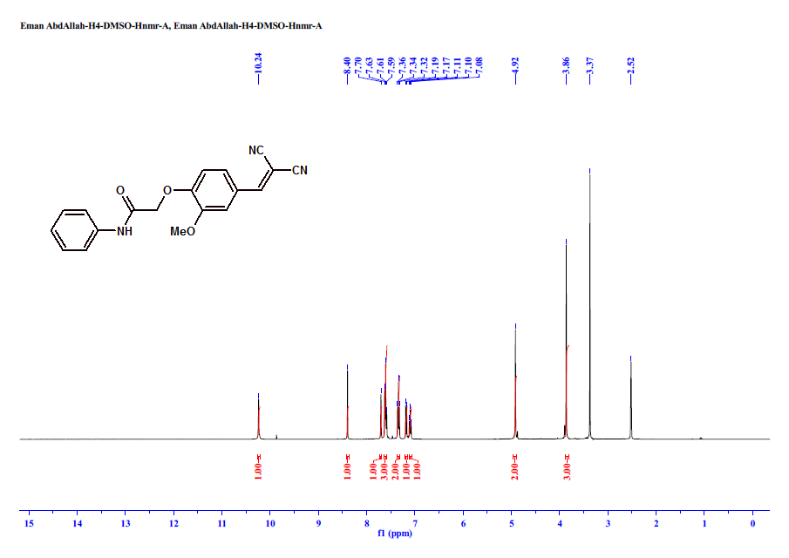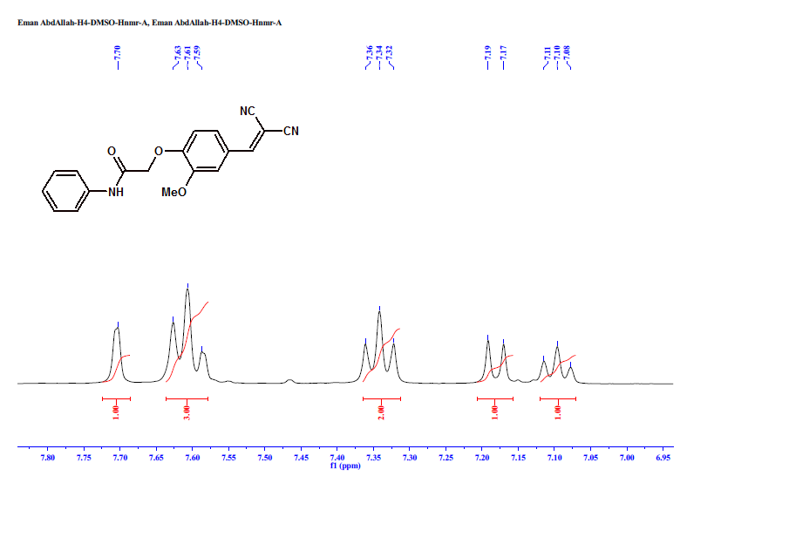

**1H NMR of compound (6a):**

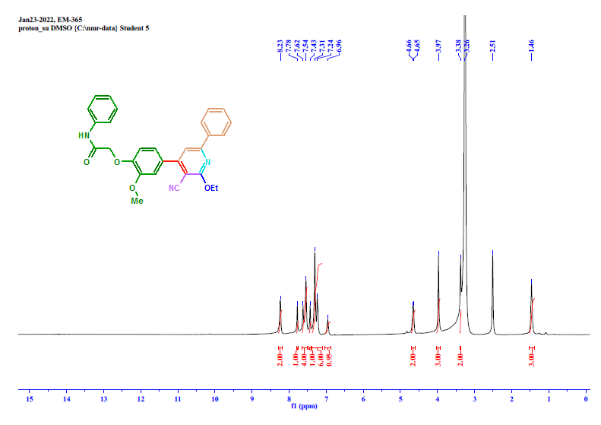 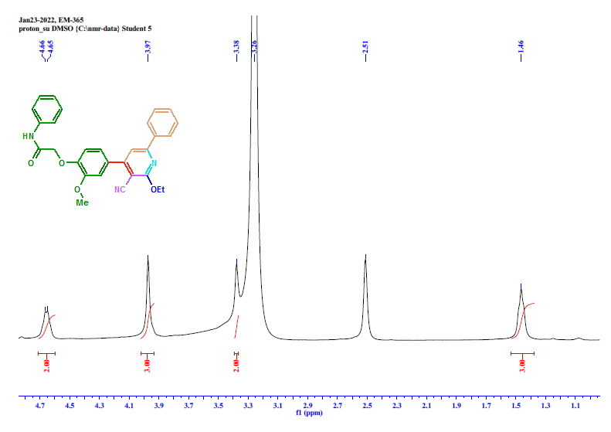

**1H NMR, 13CNMR and Dept-135 of compound 6b:**

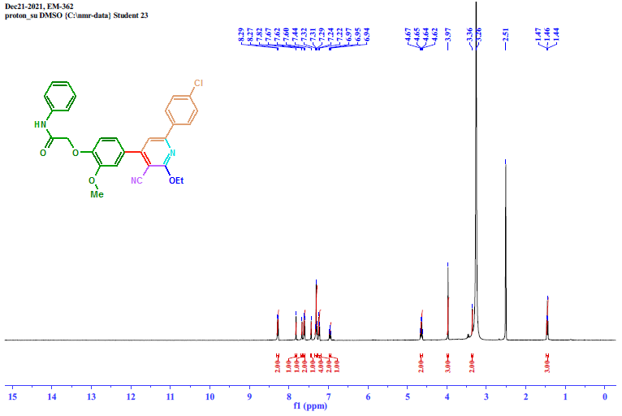 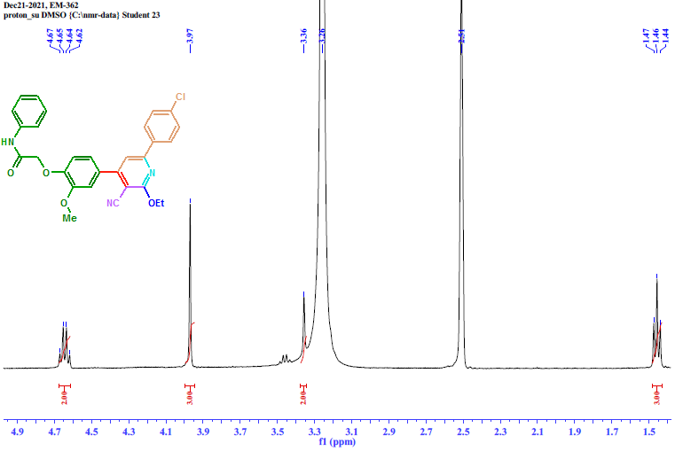

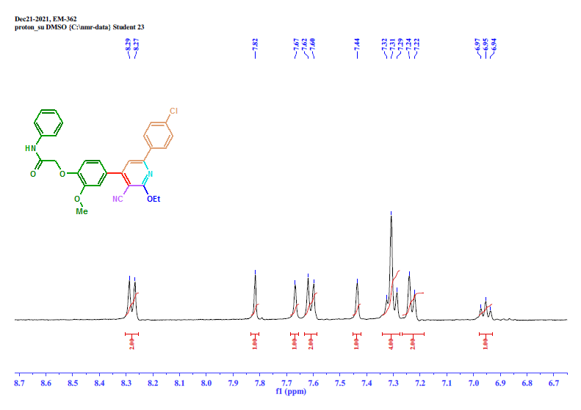 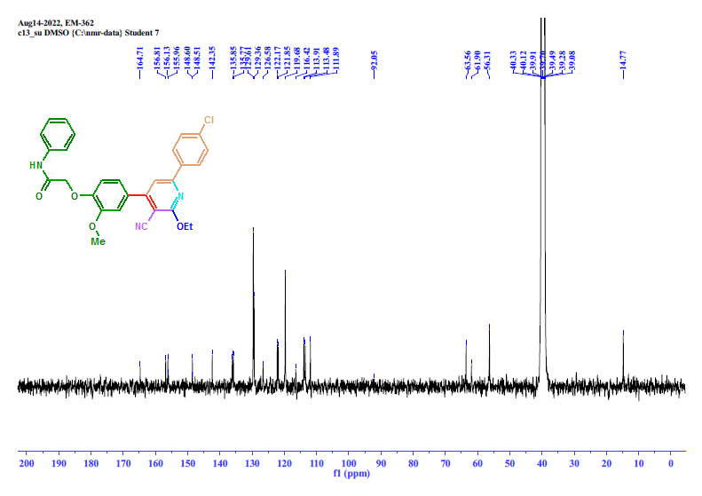 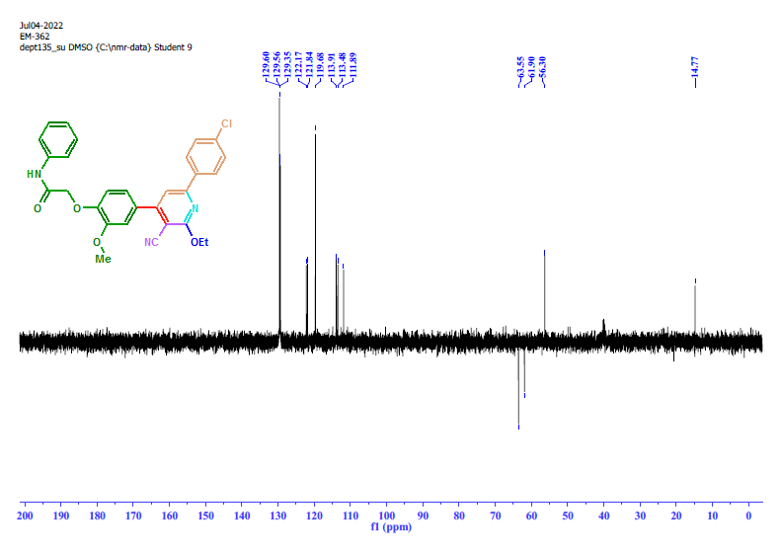

**1H NMR and 13CNMR of compound 6c:**

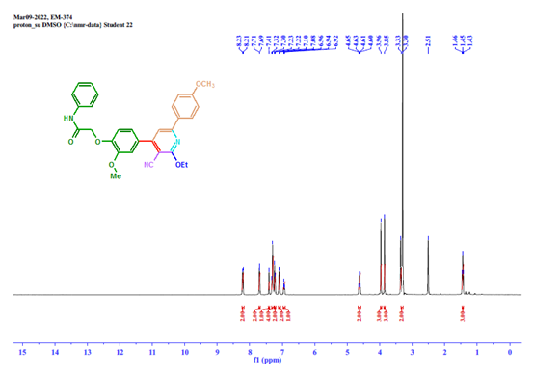

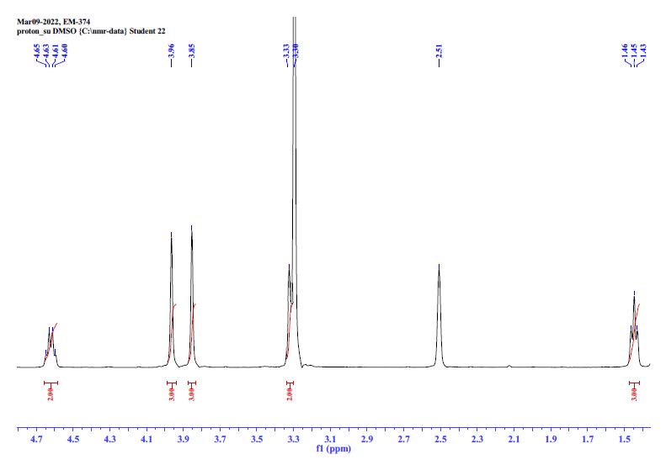

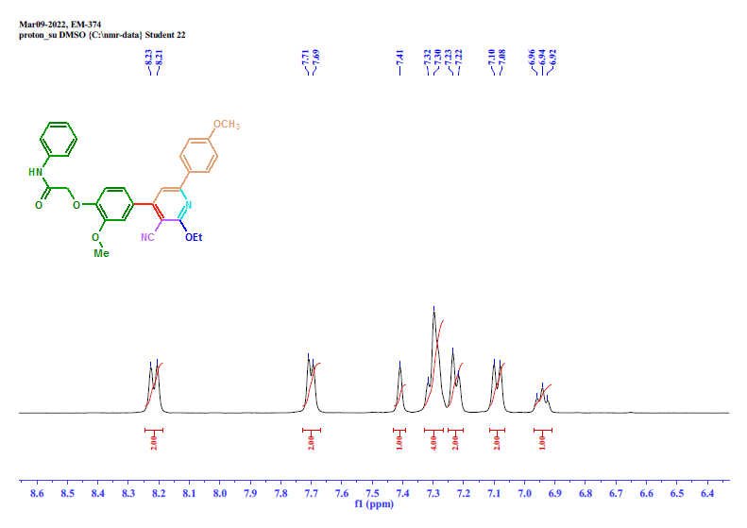

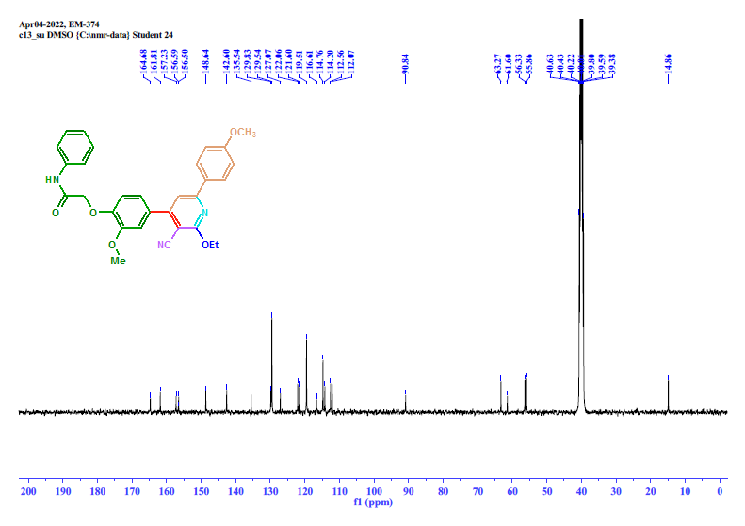

**1H NMR and 13CNMR of compound 6d:**

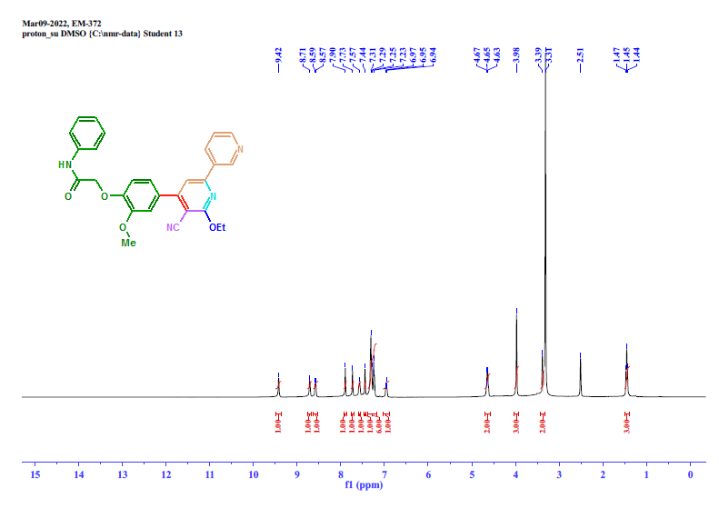

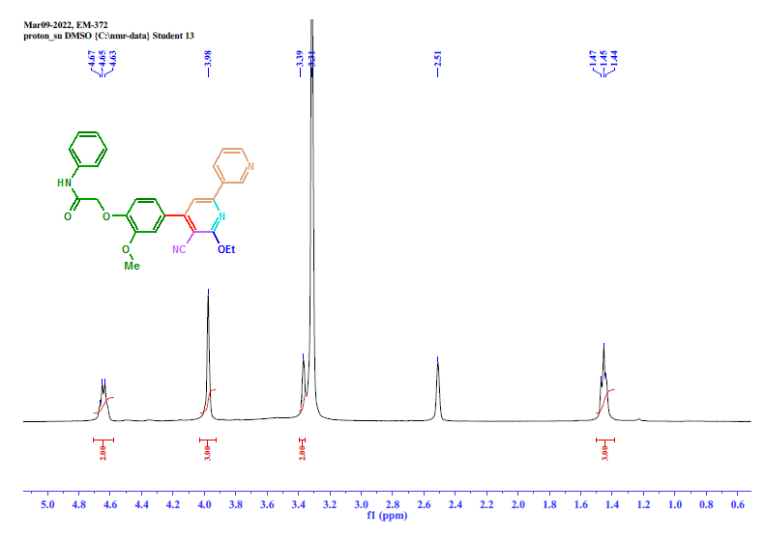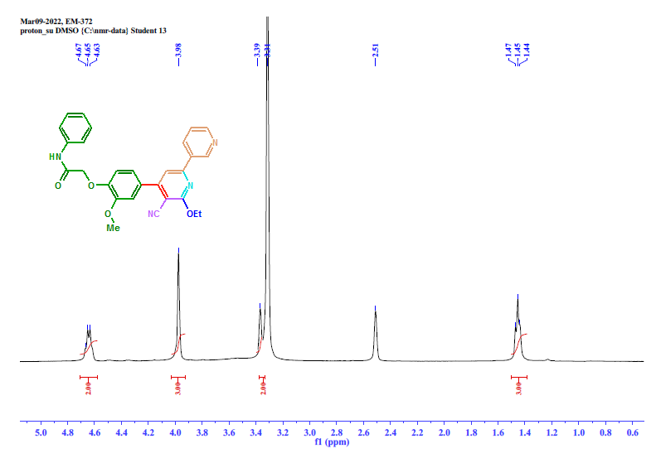

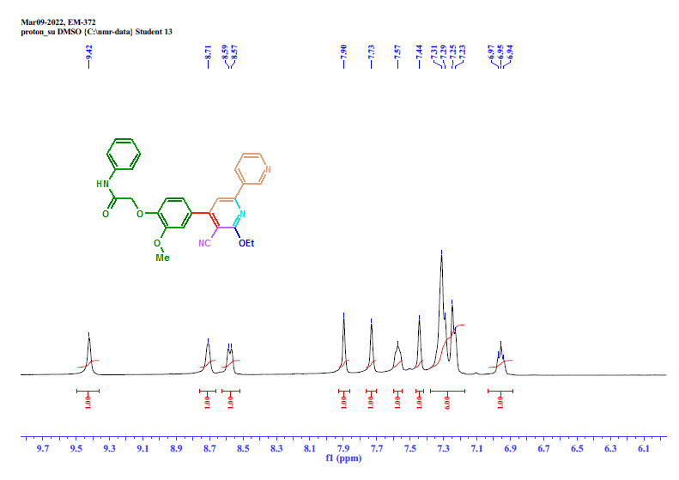

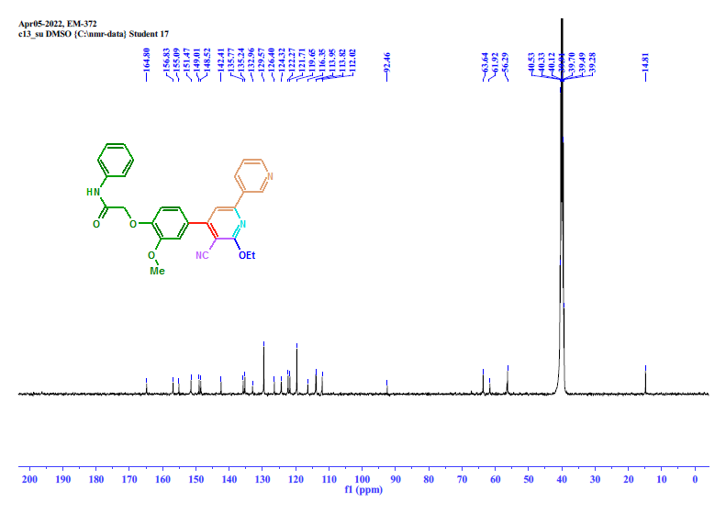

**1H NMR and 13CNMR of compound 6e:**

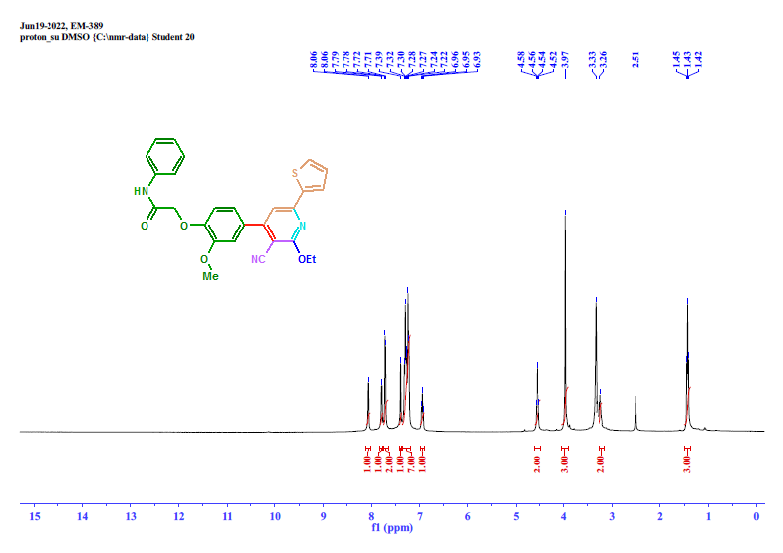 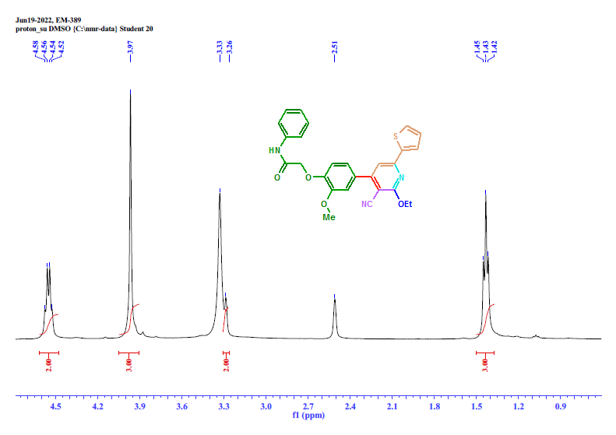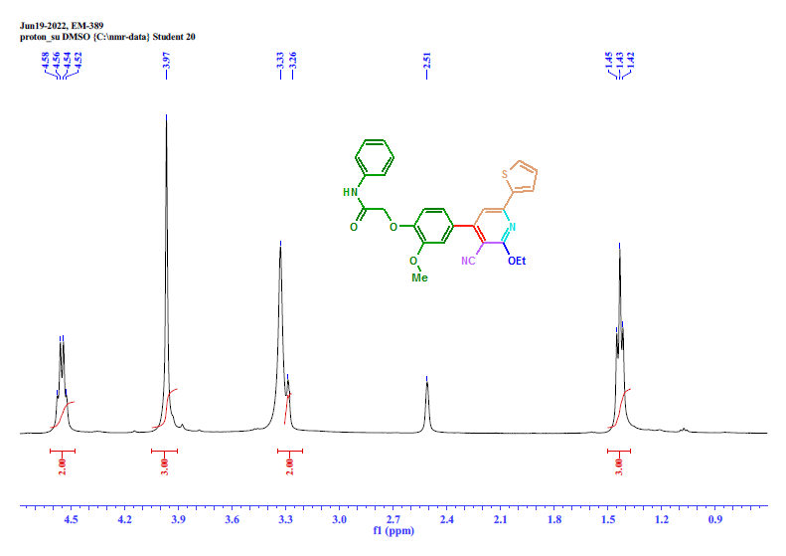 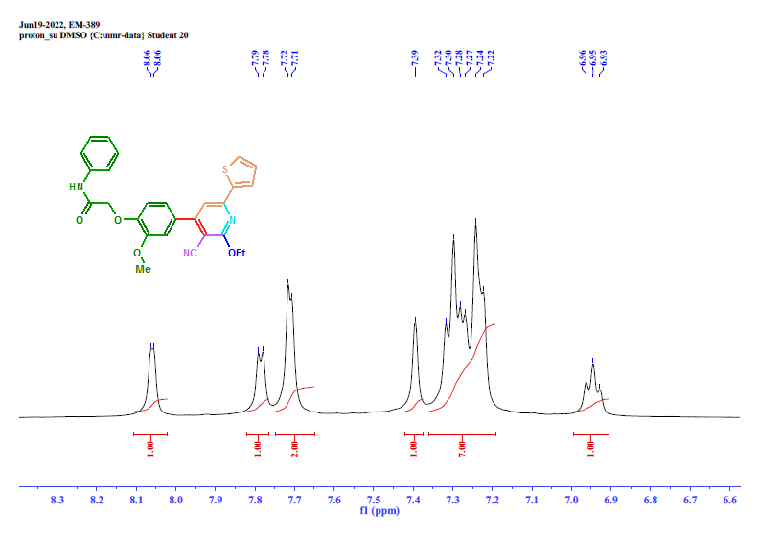 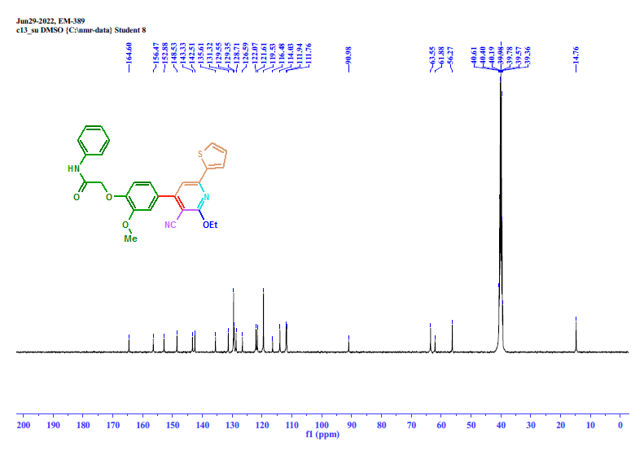 **1H NMR and 13CNMR of compound 6f:**

