**Development of new mixed Cu(II) Chelate based on 2-Benzimidazolylguanidine and Phenanthroline ligands: Structural elucidation, Biological Evaluation, DFT and Docking Approaches**

Ahmed M. Abu-Dief1,2\*, Tarek El‐Dabea1,3\*, Rafat M. El-Khatib1, Aly Abdou1, Mahmoud Abd El Aleem Ali Ali El-Remaily\*1

1Department of Chemistry, Faculty of Science, Sohag University, Sohag, 82524 Egypt

2Chemistry Department, College of Science, Taibah University, P.O. Box 344, Madinah, Saudi Arabia

3Chemistry Department, Faculty of Science, King Salman International University, Ras Sudr, Sinai 46612, Egypt

**Part 1-Instrumentation and methods**

IR spectra were registered by an apparatus of Shimadzu FT-IR model 8101 spectrometer using KBr pellets from 4000 to 400 cm-1. Elemental analyses were measured using a CHNS-932 analyzer from LECO using standard conditions in Micro-Analytical Center at Cairo University. UV-Vis. spectra were measured on a PG spectrophotometer model T þ 80 at 25 oC using 10 mm silica cells in the thermostatted cell holder. The thermostatted cell holder was supplied by an ultra thermostat water circulator (HAAKE Model F3-k). The TG/DT analyses were recorded on Shimadzu corporations TGA-60H thermal analyzer in dynamic nitrogen atmosphere (20 cm3 min1) with heating rate 5 degrees min from ambient temperature to 750oC. Melting points were obtained by a Thermo Scientific 9100 apparatus. Magnetic susceptibility measurements of the metal complexes were done on a Gouy’s balance at room temperature using Hg[Co(SCN)4] as a calibrant. Molar conductance was measured on an Elico CM-180 conductometer at 25 C using DMSO as a solvent. A HANNA 211 pH meter at 298 K equipped with a CL-51B joined electrode was used for pH measurements, calibrated against standard buffers (pH 4.02 and 9.18) before measurements. To investigate the 3D structure and molecular stability for metalcomplex, exact density functional theory (DFT) calculations were achieved using Gaussian 09 software software package. Calculations were carried out at DFT level of theory with DFT/B3LYP method. This treatment was done under valence double-zeta polarized basis set (6-31G), which treated by correlation-consistent (LANL2DZ) basis sets. The obtained files (log, chk&fchk) were visualized over Gauss View screen

**Part 2-Antimicrobial screening methodology**

The in vitro antimicrobial action for HL ligand and its Cu(II) complex were inspected against some strains of bacteria such as Gram-negative bacteria Escherichia coli (-ve) and *Salmonella Typhimurium(-ve)*, one Gram-positive bacteria *Bacillus cereus* and some strains of fungi such as *Fusariumoxysporum*,*Geotrichumcandidum*and*Aspergillusflavus*. The microbial inhibition of the ligand and its complexes were tested by utilizing the gar well diffusion process. DMSO was used as a solvent for HL and Cu(II) complex with two different concentrations (15 and 25 mg/mL) for all compounds. A cooled agar plates were prepared, and the holes were set up (1cm) after that 100 μl of each compounds with different concentration was loaded in a hole for studying the grown of the organisms on the agar. These agar plates were in an incubator for 24-72 h at 37°C. The activity was detected with an inhibition region that occurred in the zone which contained concentration of BIG ligand and their complexes by utilizing serial dilution route [from10 μg ml-1 to 0.5 μg ml-1] and other regions in the plates. The development of microorganisms was observed. Next the data were documented as zones of inhibition and were compared with standard drug such as Fluconazole (antifungal agent) and Ofloxacin for (antibacterial agent). The ranges of (MIC) minimum inhibitory concentration were estimated.

**Part 3-Antitumor screening for the tested compounds towards HCT‐116, MCF‐7 and HepG‐2**

The anticancer activity was determined at the National Cancer Institute, Cancer Biology Department, Pharmacology Department, Cairo University. The absorbance or optical density (OD) of each well was evaluated spectrophotometrically at 564 nm with an ELISA micro plate reader (Meter Tech Σ 960, USA). Estimation of the cytotoxic activity of the prepared HL ligand and its Cu(II) complex was carried out using Colon carcinoma cells (HCT‐116), hepatic cellular carcinoma cells (HepG‐2) and breast carcinoma cells (MCF‐7). The assessment process was carried out in vitro by way of utilizing sulforhodamine B stain. Cells were placed in a 96‐multiwell plate (104 cells per well) for 24 h before transmutation with the metal imine chelates to allow attachment of cells to the wall of the plate at a density of 5 × 103 cells per well. Various concentrations of the compounds (0, 1, 2.5, 5 and 10 μM) were added to the cell monolayer. Monolayer cells were incubated with the metal chelates for 48 h at 37°C and in an atmosphere of 5% CO2. After 48 h, cells were fixed, rinsed and stained with sulforhodamine B stain. Acetic acid was used to wash excess stain then the attached stain was administered with TAE buffer. Colour intensity was measured with an ELISA reader. Each concentration was tested three times and five replica wells were used for controls and vinblastine was used as standard drug. With the control wells representing 100% viability, the absorption values of each well were expressed as the percentage cell viability. IC50 was assessed and IC50 values were calculated from the dose– response curves using Origin software, representing the concentration of test compound to inhibit cell viability by 50%. Every concentration for each compound was tested in triplicate and mean values ± SD were recorded.

|  |
| --- |
|  |
|  |
| **Fig. S1:** IR-transmittance versus wave numbers (cm-1 ) for HL ligand and its CuPL chelate |

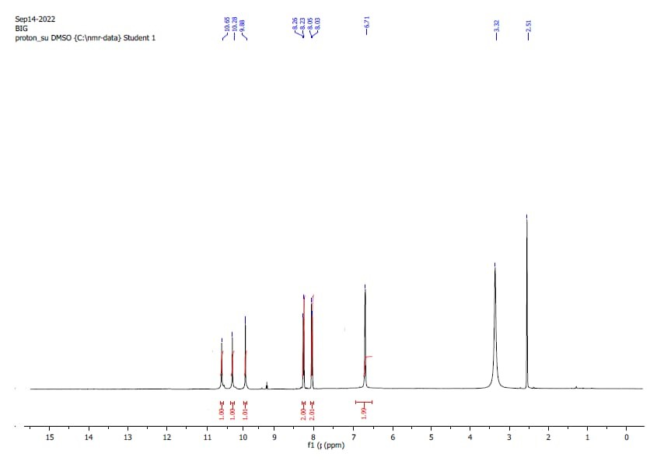

**Fig S2.**1 H NMR spectrum of the studied HL ligand

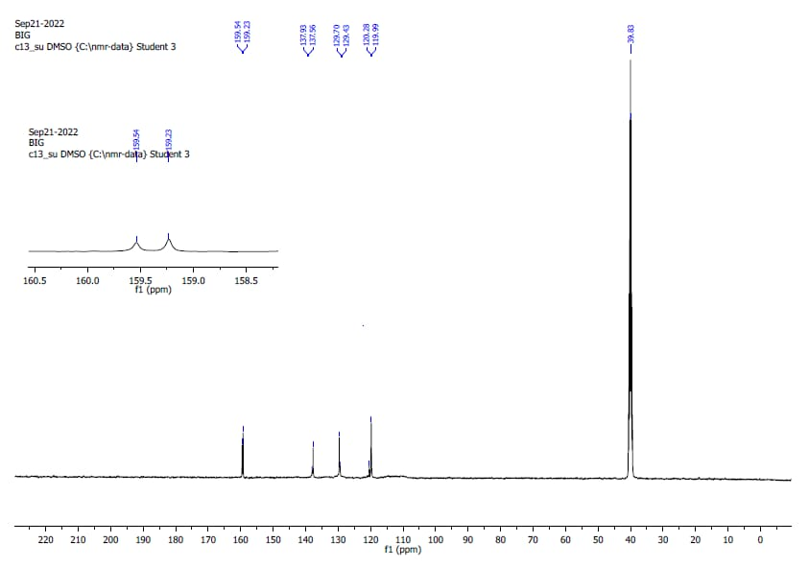

**Fig S3.**13 C NMR spectrum of the studied HL ligand

|  |
| --- |
|  |
| **Fig. S4:** TGA of the prepared CuPL complex |

|  |
| --- |
|  |
| **Fig. S5**: Curves of molar ratio method for CuPL complex (10-3M ) in DMSO at 298 K. |

|  |
| --- |
| **HL** |
| pose___1 |
| **CuPL** |
| pose__4 |
| **Figure S6:** 3D binding between the HL & CuPL with (2Vf5**)** |

|  |  |  |  |
| --- | --- | --- | --- |
| **Table S1:** **: Electronic transitions, λmax (nm) and εmax (mol-1 cm1  dm3 ) for studied compounds** | | | |
| **Ligands and their complexes** | **ɛ max**  **(mol-1 cm1  dm3 (** | **λ max(nm)** | **Assignment** |
| **HL** | 1916  1911  560 | 293  308  447 | π→π\*  n→π\*  T2g—π\* |
| **CuPL** | 1691  1603  1010  247  203 | 291  322  362  523  601 | π→π\*  n→π\*  T2g—π\*  MLCT band  d→d |

|  |  |  |  |  |  |  |  |  |  |
| --- | --- | --- | --- | --- | --- | --- | --- | --- | --- |
| Table S2: TGA degradation steps for CuPL complex | | | | | | | | | |
| Complex | **TG range (oC)** | **Mass**  **loss found (calcd) %** | **Assign-ment** | **Residues**  **found (calcd) %** | **A**  **(S-1)** | ***∆H\****  **(KJmol-1)** | ***∆S\****  **(Jmol-1K-1)** | ***E\****  **(KJmol-1)** | ***∆G\****  **(KJmol-1)** |
| CuPL | 48 - 116 oC | 3.29  (3.24) | H2O | Ag  11.33  (11.45) | 0.024 | 36.54 | -277.31 | 39.49 | 134.98 |
| 118 - 380 oC | 53.7  (53.73) | C16H14N2O4 | 35.15 | -280.51 | 181.58 |
| 382 - 560 oC | 10.50  (10.45) | CH4N3 | 33.31 | -283.46 | 244.2 |
|  | 562 - 720 oC | 21.14  (21.09) | C7H5N2 |  |  | 31.89 | -285.17 | 292.53 |

|  |  |  |  |  |  |  |
| --- | --- | --- | --- | --- | --- | --- |
| **Table S3:** MOE- docking results of the studied moleclues with **3cku** | | | | | | |
| **Compound** | **Ligand** | **Interaction** | **Receptor** | **E (kcal/mol)** | **Distance** | **S (kcal/mol)** |
| HL | N 7 | GLU 259 | H-donor | 2.92 | -3.30 | -4.52 |
| CuPL | C27 | GLU 259 | H-donor | 3.05 | -1.00 | -8.34 |
| N48 | GLU 259 | H-donor | 2.86 | -5.10 |
| N49 | GLU 259 | ionic | 3.23 | -3.10 |
| 6-ring | LEU 170 | pi-H | 4.59 | -0.70 |
| 5-ring | LYS 171 | pi-H | 4.31 | -0.70 |

|  |  |  |  |  |  |  |
| --- | --- | --- | --- | --- | --- | --- |
| **Table S4:** Molecular docking data of the title compounds and the 5IJT | | | | | | |
|  | **Ligand** | **Receptor** | **Interaction** | **Distance** | **E (kcal/mol)** | **S (kcal/mol)** |
| HL | N 12 | GLU 170 | H-donor | 2.91 | -4.8 | -4.66 |
| CuPL | C24 | GLU 27 | H-donor | 3.4 | -0.7 | -8.18 |
| N43 | GLU 122 | H-donor | 3.05 | -3.2 |
| N46 | ASP 121 | H-donor | 3.23 | -5.6 |
| O11 | GLN 80 | H-acceptor | 2.96 | -1.3 |

|  |  |  |
| --- | --- | --- |
| **Table S5:**  Activity index for anti-microbial assessments of HL and its CuPL complex against selected bacteria and fungi | | |
| **Compounds** | **Activity index (%)** | |
| **Conc.(µg/ml)** | **HL, [17]** | **CuPL** |
| ***S.Typhimurium (-ve)*** | 37.11 | 90.48 |
| ***Escherichia Coli(-ve)*** | 39.45 | 88.01 |
| ***Bacillus cereus (+ve)*** | 44.91 | 90.97 |
| ***Aspergillus Flavus*** | 42.02 | 85.44 |
| ***Getrichm Candidum*** | 43.23 | 91.58 |
| ***Fusarium Oxysporum*** | 57 | 85.64 |

|  |  |  |  |
| --- | --- | --- | --- |
| **Table S6:**  Cytotoxic activity (IC50) of HL and its CuPL complexagainst HCT-116, HepG-2 and MCF-7 cell lines | | | |
| **Compounds** | **IC50(µg/µl)** | | |
| **Conc.(µg/ml)** | **HL, [17]** | **CuPL** | **Doxorubicin** |
| **MCF-7** | 20.35±0.14 | 6.53±0.14 | 4.85±0.13 |
| **HepG-2** | 23.15±0.15 | 8.75±0.09 | 5.55±0.07 |
| **HCT-116** | 26.55±0.11 | 9.75±0.18 | 6.05±0.14 |