Insecticidal Evaluation and Structure-Activity Relationship Study of Some Synthesized Urea and Thiourea Derivatives Against Spodoptera Littoralis (Boisd.)
Ahmed M. M. El-Saghier¹, Mohamed A. Gad², Safwat A. Aref²,
Nabila A. Ahmed², Antar A. Abdlhamid^{1,3}
¹Department of Chemistry, Faculty of Science, Sohag University, Sohag 8252, Egypt.
²Research Institute of Plant Protection, Agricultural Research Center, 12619 Giza, Egypt.
³Department of Chemistry, Faculty of Science, Al-Baha University, Al-Baha 1988, Saudi Arabia.

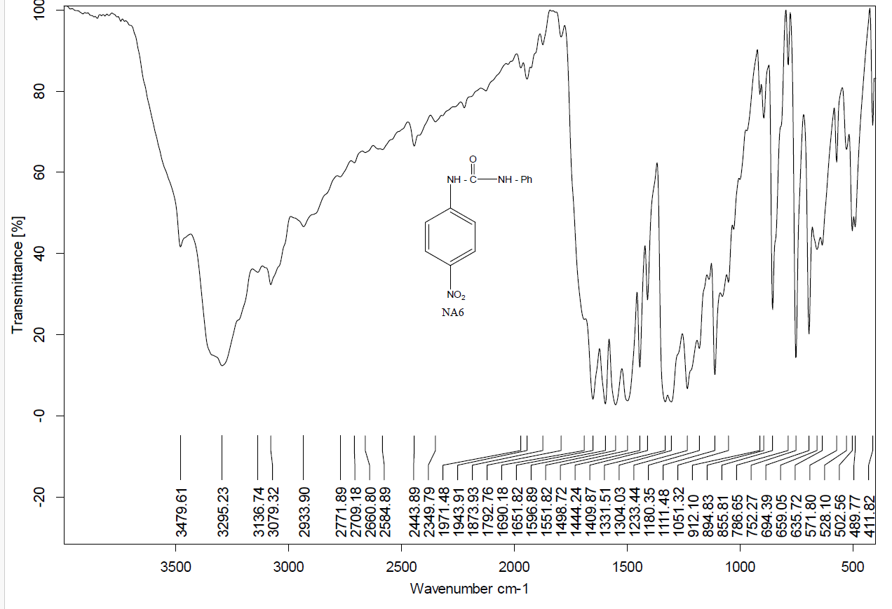

Figure N4: IR Spectrum of compound 3a
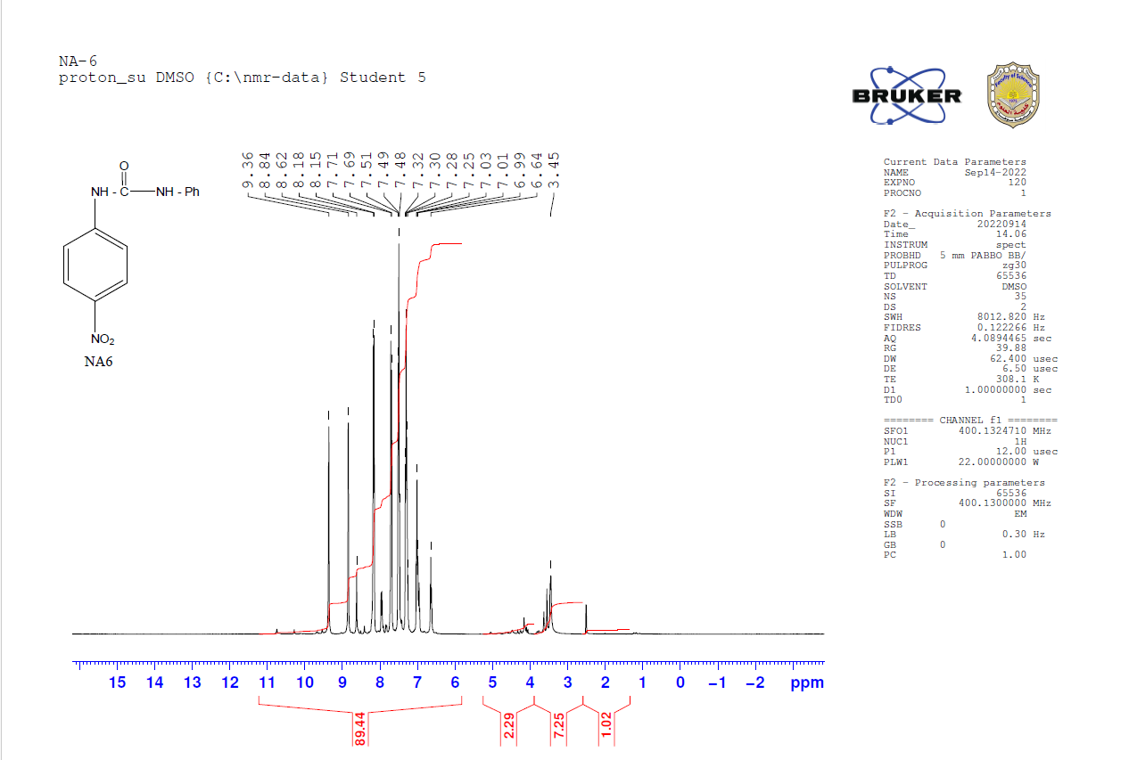
Figure N5: ¹HNMR Spectrum of compound 3a
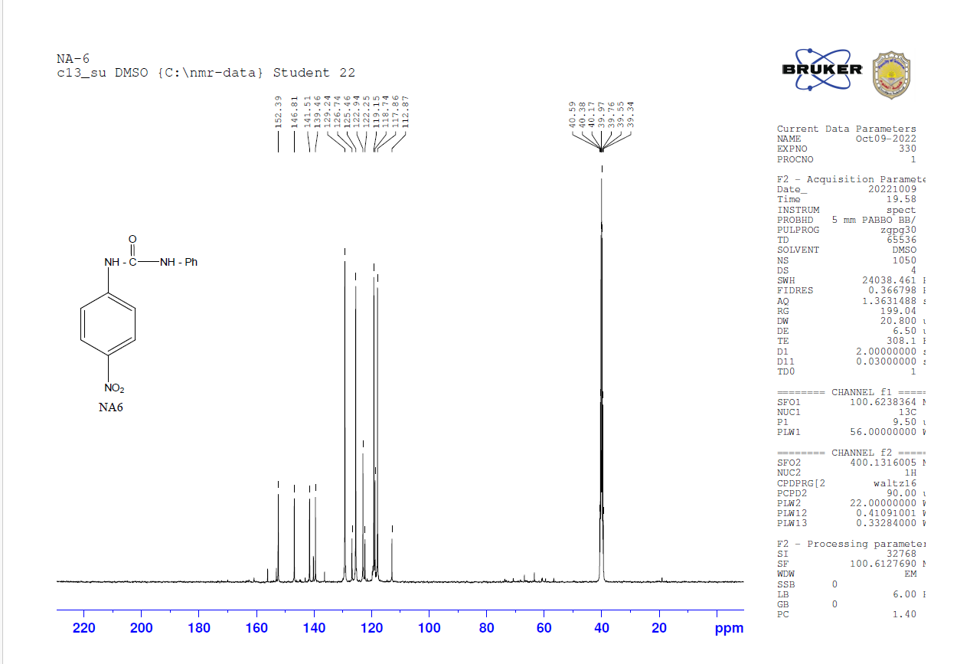
Figure N6: ¹³CNMR Spectrum of compound3a

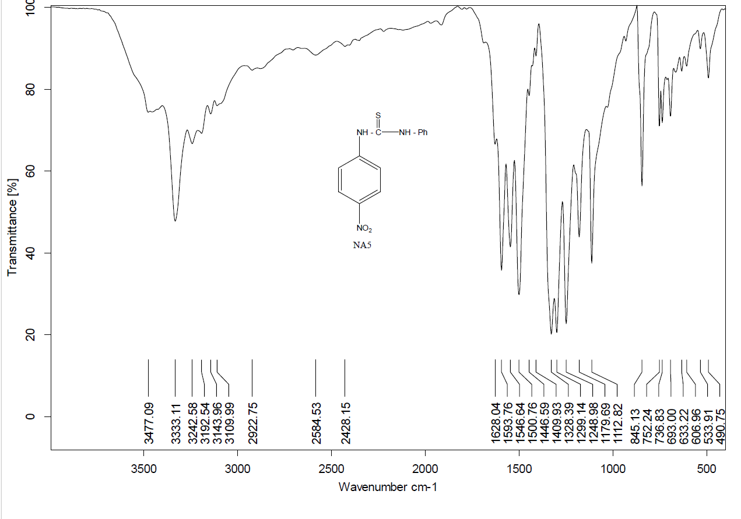
Figure N1: IR Spectrum of compound 3b

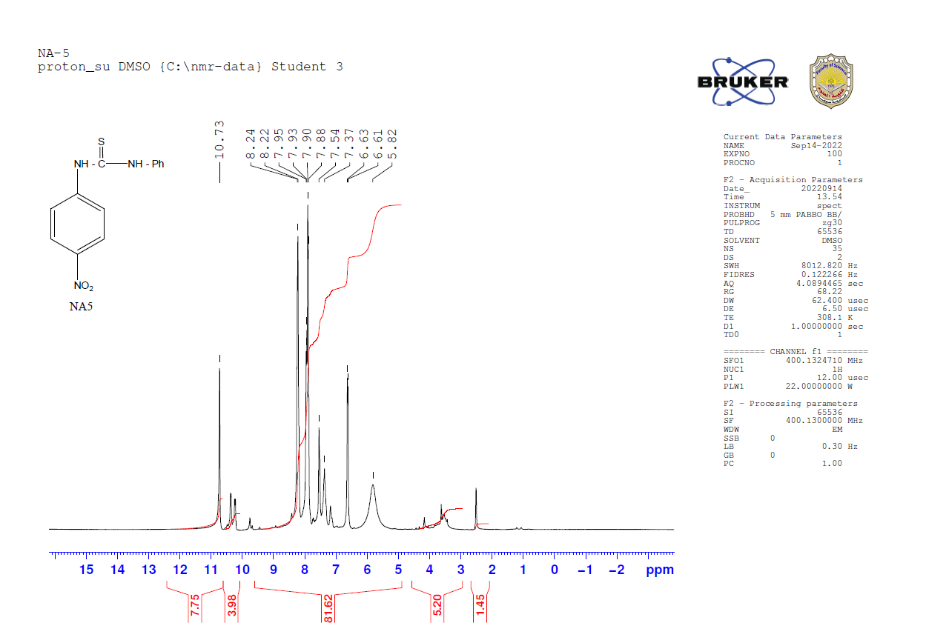
Figure N2: ¹HNMR Spectrum of compound 3b

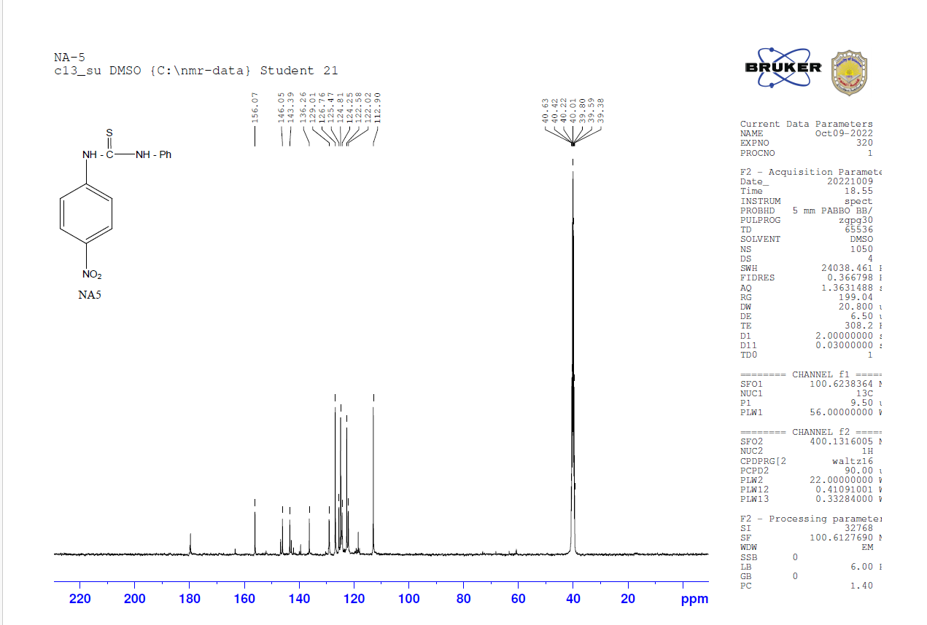
Figure N3: ¹³CNMR Spectrum of compound 3b

